**WEEK-1**

**Installation of various hypervisors and instantiation of VMs with image file using open-source hypervisors such as Virtual Box, VMWare Player, Xen and KVM.**

# 1. Objective

The below tutorial will help you to easily install VirtualBox on the host OS installed on your machine. In VirtualBox, we can easily run a number of guest operating systems depending upon your hardware configurations. Virtual Box saves system’s memory by configuring a number of OS on it, rather than individually installing them. And we can also install a number of setups and services on it.

So, let’s see how to install VirtualBox(Oracle VM VirtualBox)?

# 2. VirtualBox Download Link

You can download the latest version of VirtualBox from the Virtual Box website: [**https://www.virtualbox.org/wiki/Downloads**](https://www.virtualbox.org/wiki/Downloads)according to the version of your operating system Windows, Mac or Linux.

If you’re running Windows operating system, download the Windows version at the top by clicking “x86/amd64”  
Go to DOWNLOAD folder at your desktop.

Run the VirtualBox-4.3.16-95972-Win.exe file. **Oracle VM Virtual Box Installation** Window will appear.

# 3. Steps to Install VirtualBox

Below are the very easy steps with screenshots containing the installation procedure of Virtual Box. With the help of the below screenshots, you can install VirtualBox on your system without taking help of anyone for a single time.

**3.1. Click Next**

[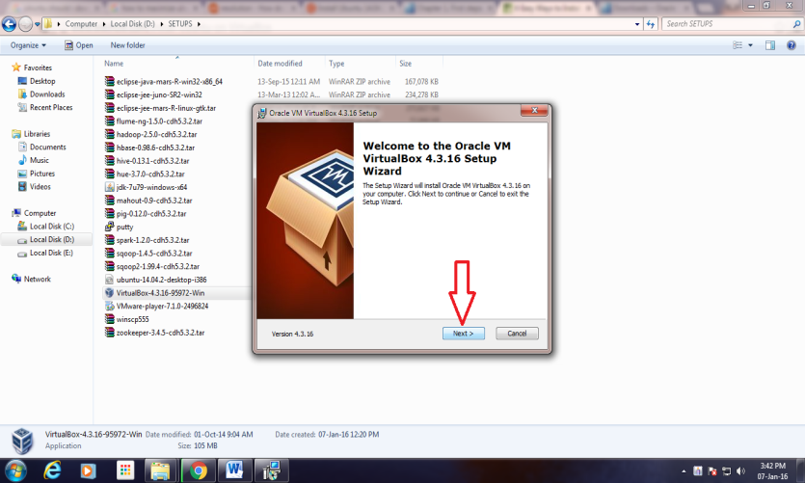](https://data-flair.training/blogs/wp-content/uploads/sites/2/2016/06/Setup-Wizard.png)

## 3.2. Click Next

[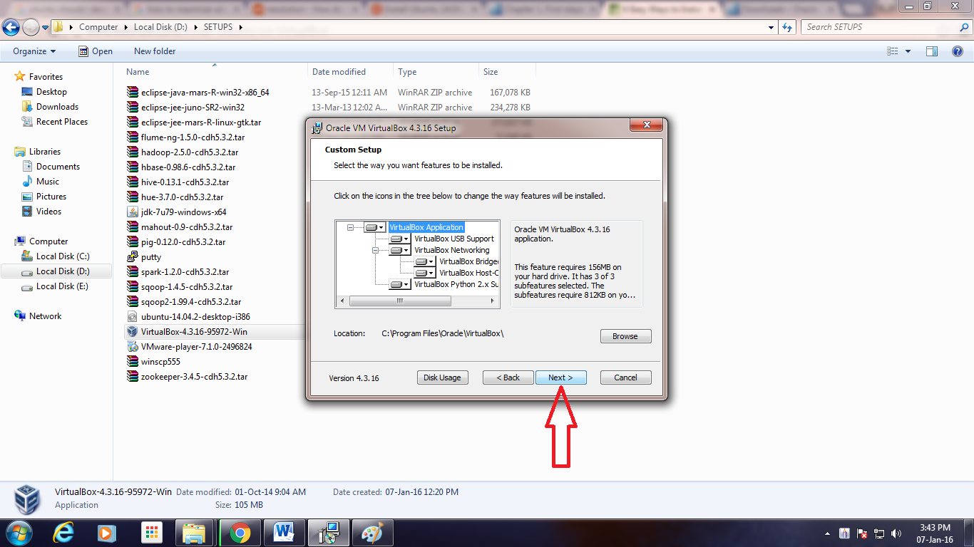](https://data-flair.training/blogs/wp-content/uploads/sites/2/2016/06/Custom-Setup.png)

## 3.3. Uncheck “Create a shortcut in the Quick Launch Bar” and click “Next”

[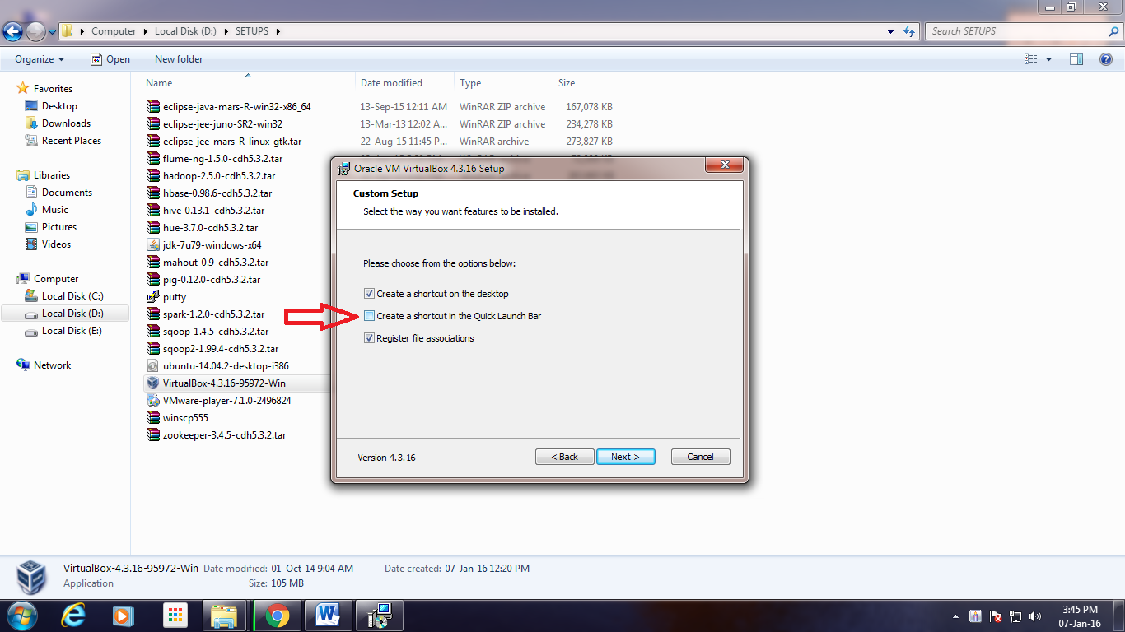](https://data-flair.training/blogs/wp-content/uploads/sites/2/2016/06/Features-Selection.png)

*Step 3. To Install VirtualBox – Features Selection*

## 3.4. Click “Yes”

[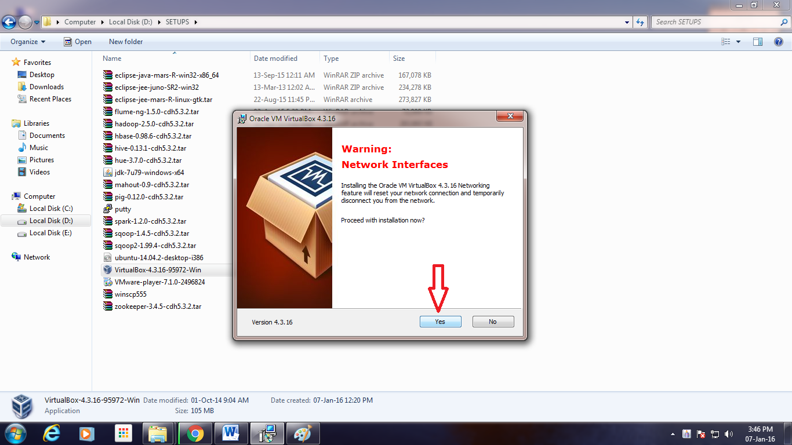](https://data-flair.training/blogs/wp-content/uploads/sites/2/2016/06/Network-Interfaces-Warning.png)

*Step 4. To Install VirtualBox – Network Interfaces Warning*

## 3.5. Click “Install”

[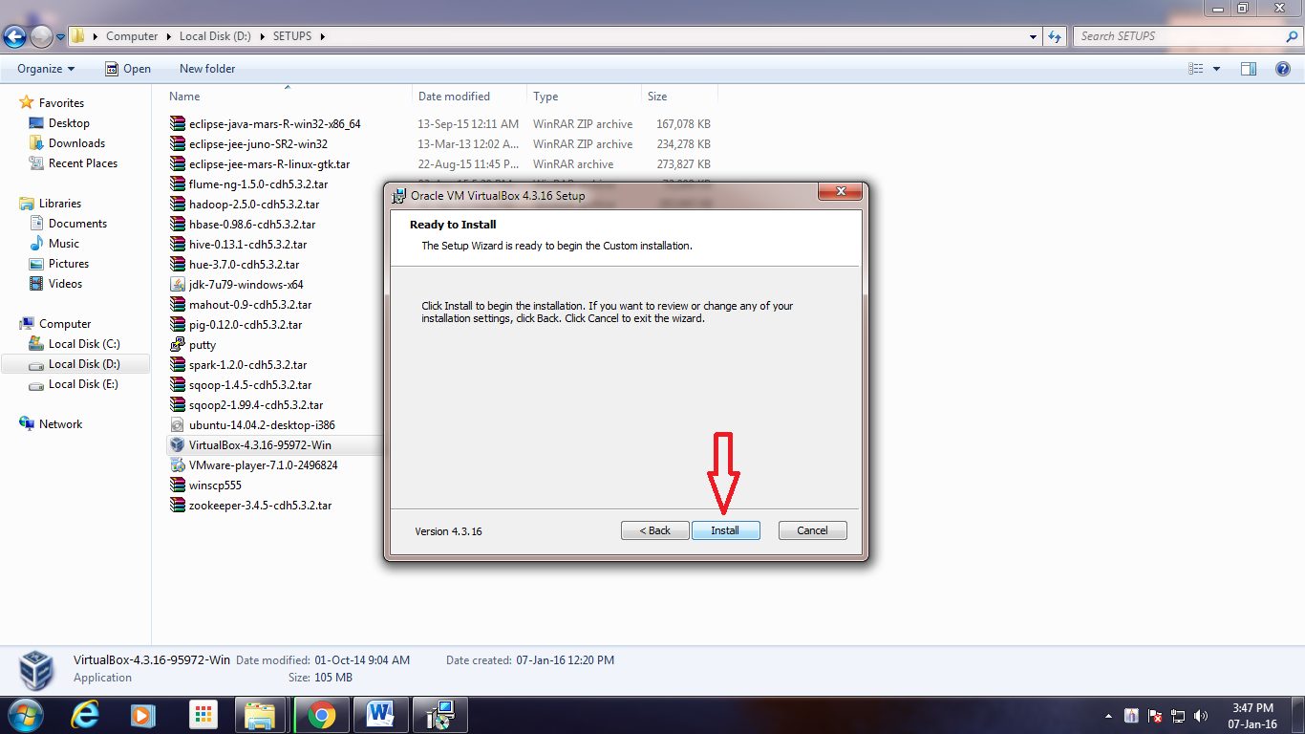](https://data-flair.training/blogs/wp-content/uploads/sites/2/2016/06/Ready-to-Install.png)

*Step 5.Installation of Oracle VM VirtualBox – Ready to Install*

## 3.6. Click “Install”

[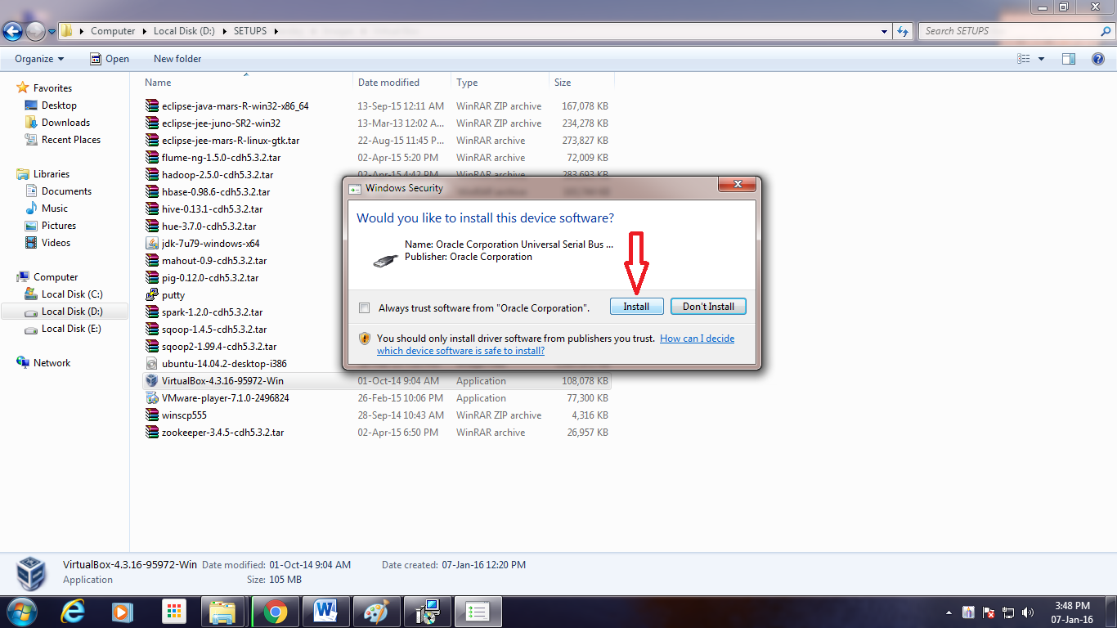](https://data-flair.training/blogs/wp-content/uploads/sites/2/2016/06/Serial-Bus-Software-Installation.png)

*Step 6.Installation of Oracle VM VirtualBox- Serial Bus Software Installation*

## 3.7. Click “Install”

[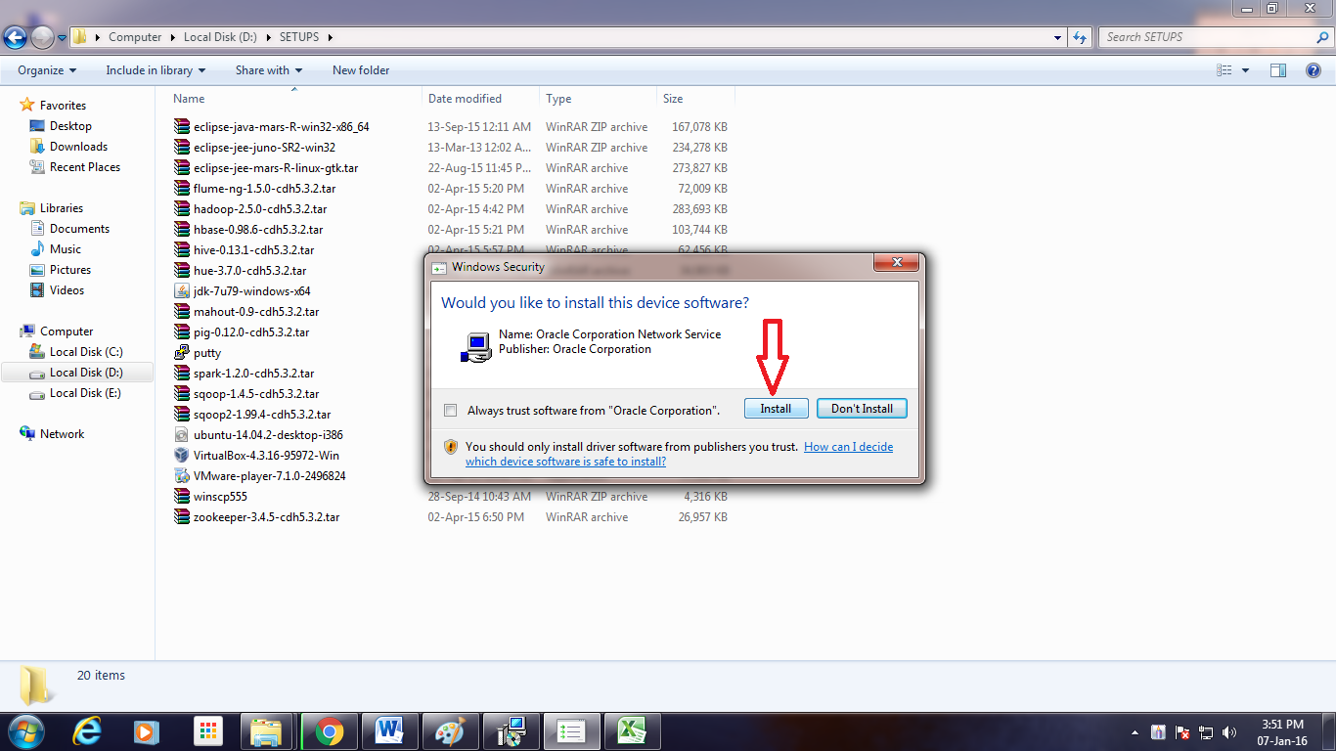](https://data-flair.training/blogs/wp-content/uploads/sites/2/2016/06/Network-Service-Installation.png)

*Step 7.Installation of Oracle VM VirtualBox – Network Service Installation*

## 3.8. Click “Install”

[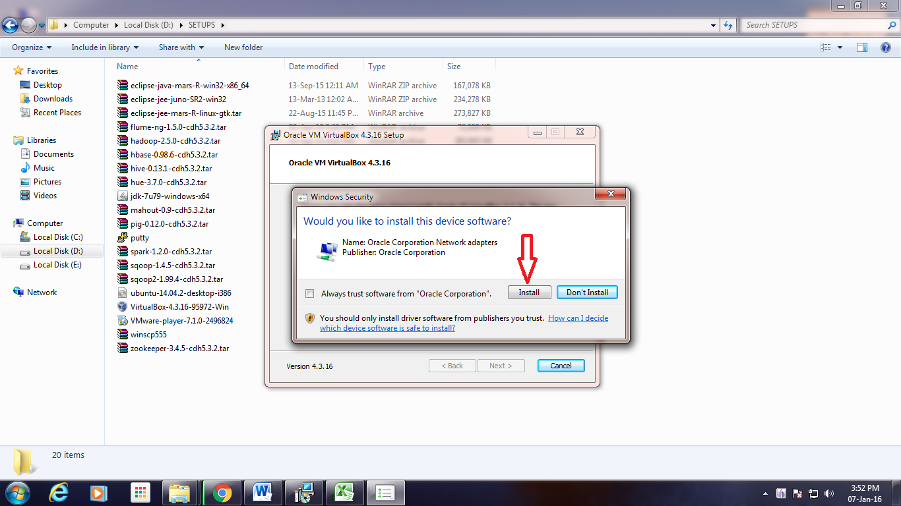](https://data-flair.training/blogs/wp-content/uploads/sites/2/2016/06/Network-Adapters-Installation.png)

*Step 8.Installation of Oracle VM VirtualBox – Network Adapters Installation*

## 3.9. Click “Finish”

[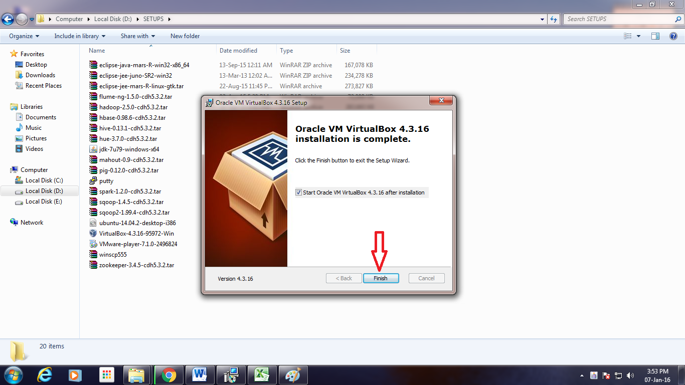](https://data-flair.training/blogs/wp-content/uploads/sites/2/2016/06/Exit-Setup-Wizard.png)

*Step 9. Installation of Oracle VM VirtualBox- Exit Setup Wizard*

## 3.10. After completion of Installation process, the Virtual Box Window gets opened

[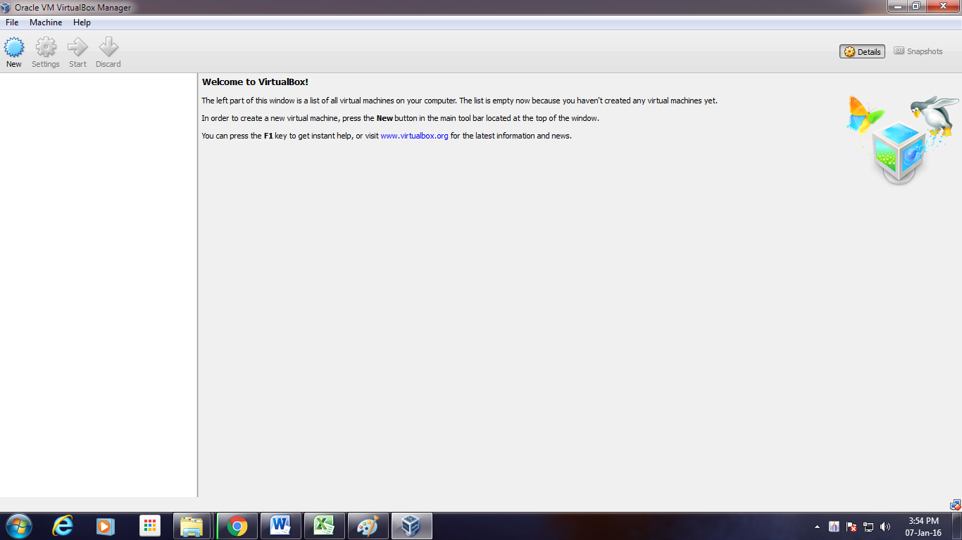](https://data-flair.training/blogs/wp-content/uploads/sites/2/2016/06/Virtual-Box-Window.png)

*Step 10. Installation of Oracle VM VirtualBox – Virtual Box Window gets opened*

# How to run an Ubuntu Desktop virtual machine using VirtualBox 7

Download an Ubuntu Image

Duration: 3:00

You can download an Ubuntu image [here](https://ubuntu.com/download/desktop). Make sure to save it to a memorable location on your PC! For this tutorial, we will use the latest Ubuntu 22.10 release.

[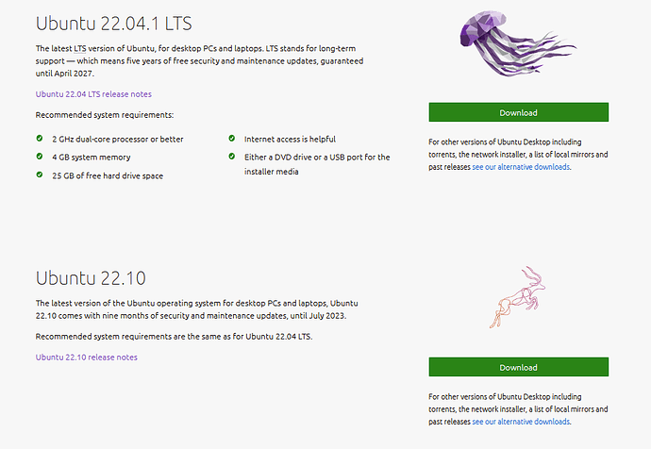](https://ubuntucommunity.s3.dualstack.us-east-2.amazonaws.com/original/3X/b/5/b58c62a68cbe82095e2625b8dd3d0d19769fd71c.png)

Download and install VirtualBox

Duration: 5:00

You can download VirtualBox from the downloads page [here](https://www.virtualbox.org/wiki/Downloads). This page includes instructions on how to install VirtualBox for your specific OS so we won’t repeat those here.

Once you have completed the installation, go ahead and run VirtualBox.

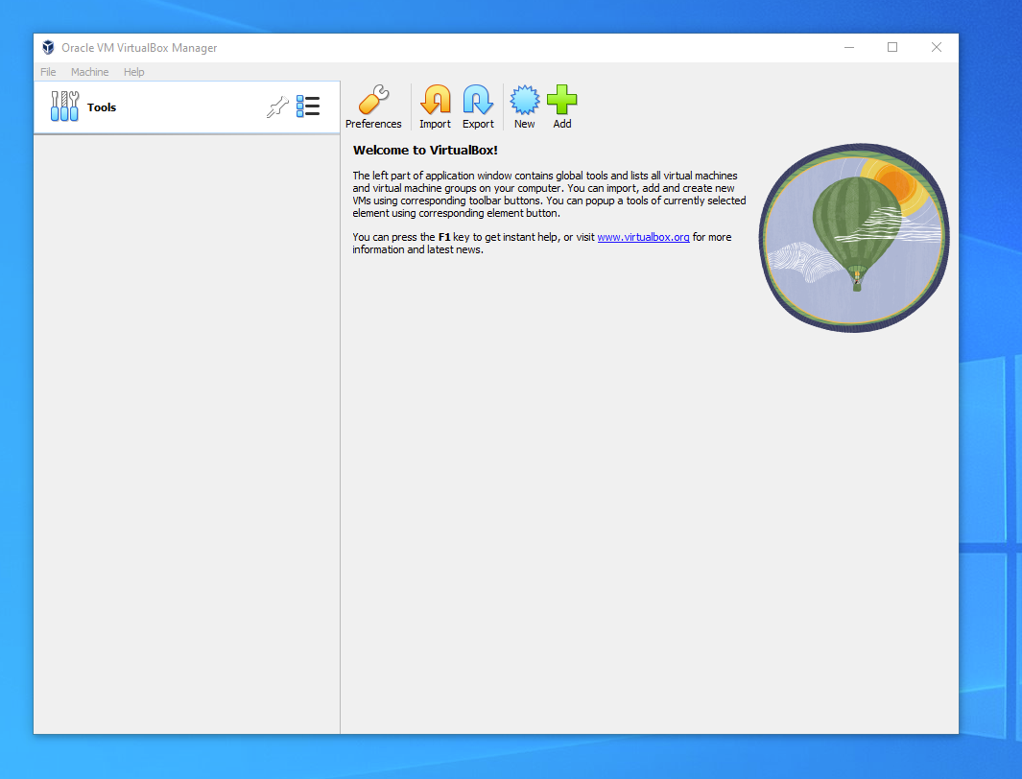

## 2. Create a new virtual machine

Click **New** to create a new virtual machine. Fill in the appropriate details:

* Name: If you include the word Ubuntu in your name the Type and Version will auto-update.
* Machine Folder: This is where your virtual machines will be stored so you can resume working on them whenever you like.
* ISO Image: Here you need to add a link to the ISO you downloaded from the Ubuntu website.

We want to install Ubuntu unattendedly so we can leave the checkbox to skip unchecked.

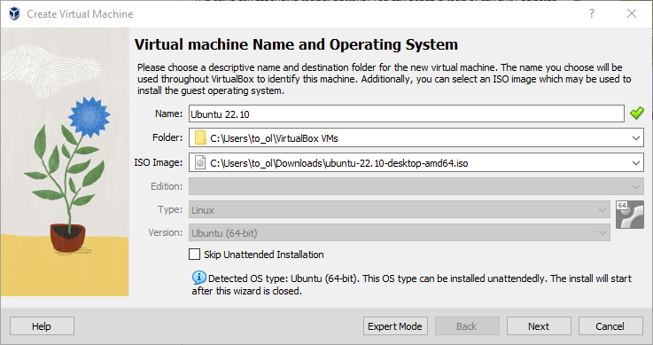

### Create a user profile

To enable the automatic install we need to prepopulate our username and password here in addition to our machine name so that it can be configured automatically during first boot.

The default credentials are:

* Username: vboxuser
* Password: changeme

It is important to **change these values** since the defaults will create a user without sudo access.

Ensure your Hostname has no spaces to proceed!

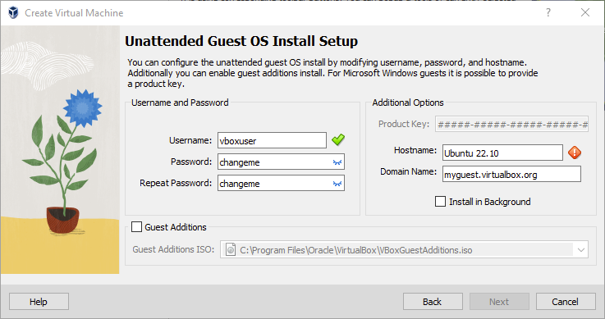

It is also recommended to check the **Guest Additions** box to install the default Guest Additions ISO that is downloaded as part of VirtualBox. Guest additions enables a number of quality of life features such as changing resolution and dynamic screen resizing so it is highly recommended!

**Note:** If you choose not to use unattended install then this step will be skipped and you will go straight to the following screen. Once your machine has been created you will be able to create a username and password by proceeding through the standard [Ubuntu Desktop installation flow](https://ubuntu.com/tutorials/install-ubuntu-desktop#4-boot-from-usb-flash-drive) on first boot.

### Define the Virtual Machine’s resources

In the next section we can specifiy how much of our host machine’s memory and processors the virtual machine can use. For good performance it’s recommended to provide your VM with around 8GB of RAM (althought 4GB will still be usable) and 4 CPUs. Try to remain in the green areas of each slider to prevent issues with your machine running both the VM and the host OS.

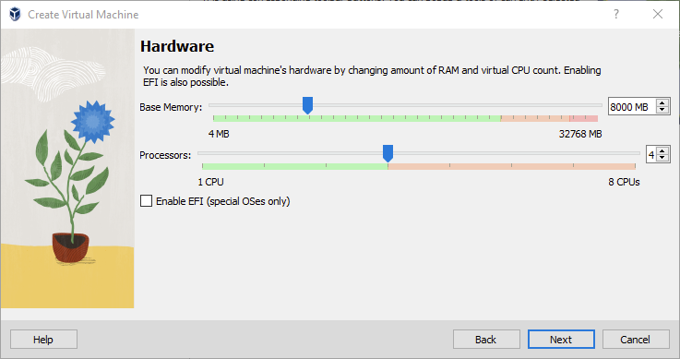

Then we need to specify the size of the hard disc for the virtual machine. For Ubuntu we recommend around 25 GB as a minimum. By default the hard disk will scale dynamically as more memory is required up to the defined limit. If you want to pre-allocate the full amount, check the ‘Pre-allocate Full Size’ check box. This will improve performance but may take up unnecessary space.

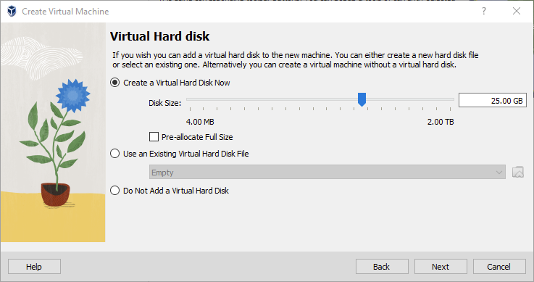

Click **Next** to continue and view a summary of your machine setting.

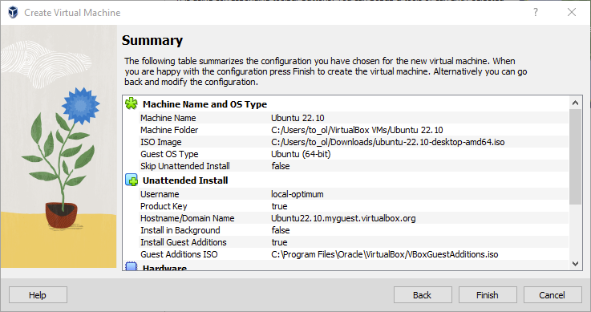

After this click **Finish** to initialize the machine!

## 3. Install your image

Click **Start** to launch the virtual machine.

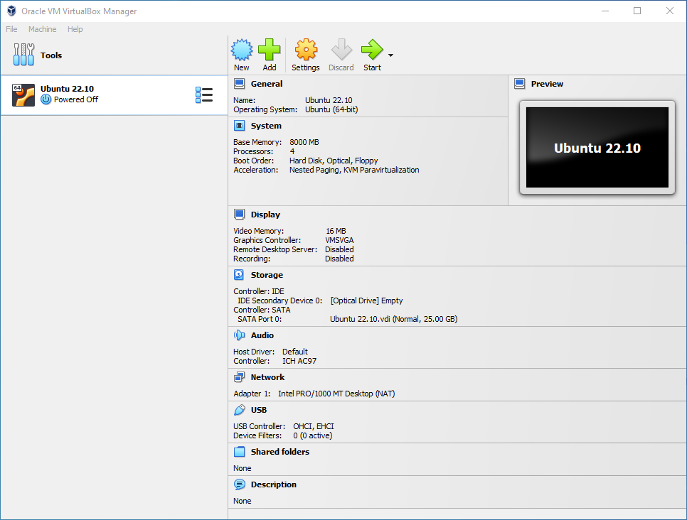

You will see a message saying ‘Powering VM up …’ and your desktop window will appear.

On first boot the unattended installation will kick in so do not interact with the prompt to ‘Try and Install Ubuntu’ and let it progress automatically to the splash screen and into the installer.

**Note:** If you chose not to use unattended install then you will need to progress through the Ubuntu install manually. Check out our [Ubuntu Desktop installation tutorial](https://ubuntu.com/tutorials/install-ubuntu-desktop#4-boot-from-usb-flash-drive) for more details.

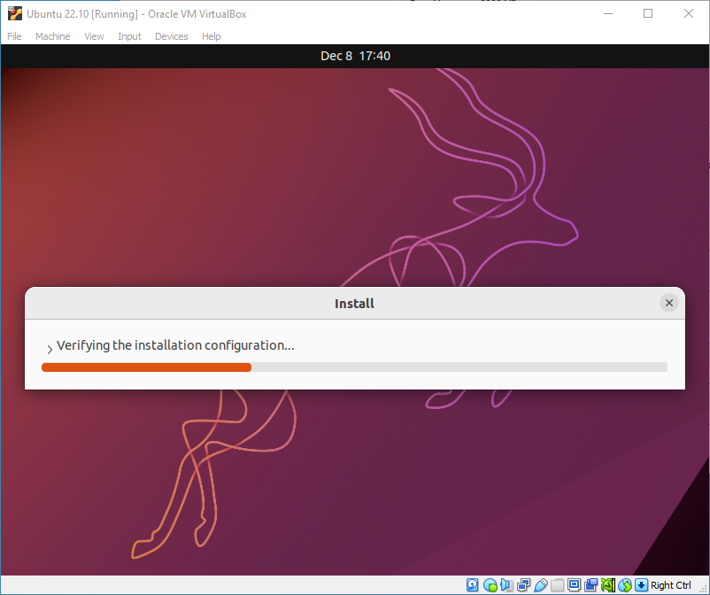

You will notice at this stage that the resolution of the window is fixed at 800x600. This is because the Guest Additions features are not installed until after the Ubuntu installation has completed.

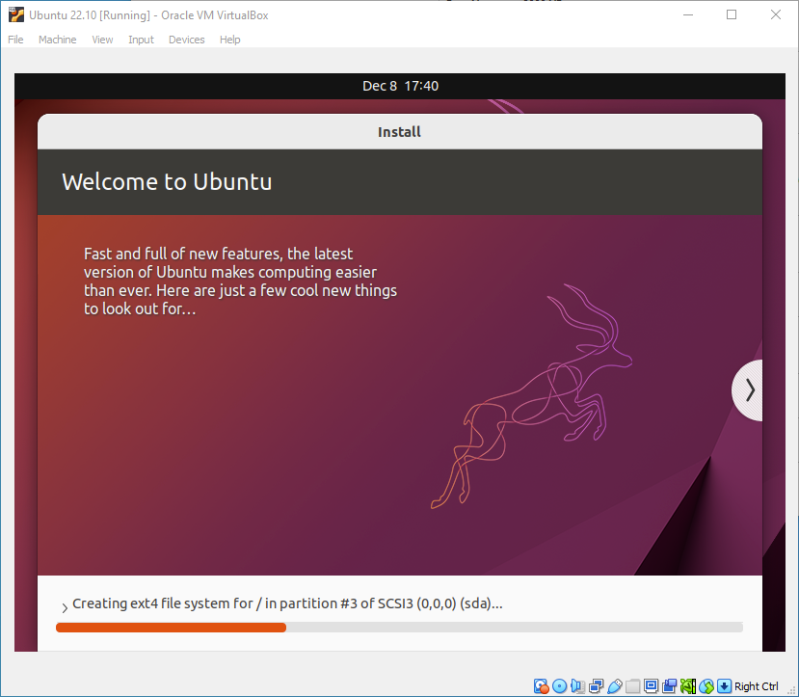

Once the installation completes, the machine will automatically reboot to complete the installation.

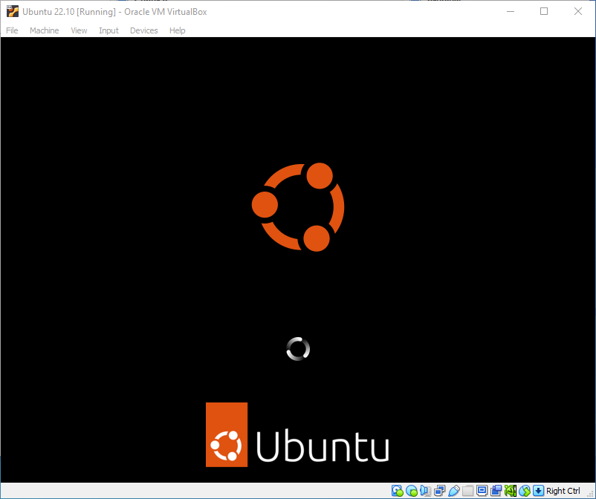

Finally you will be greeted with the Ubuntu log-in screen where you can enter your username and password defined during the initial setup (don’t forget that the default password is ‘changeme’ if you left everything as the default).

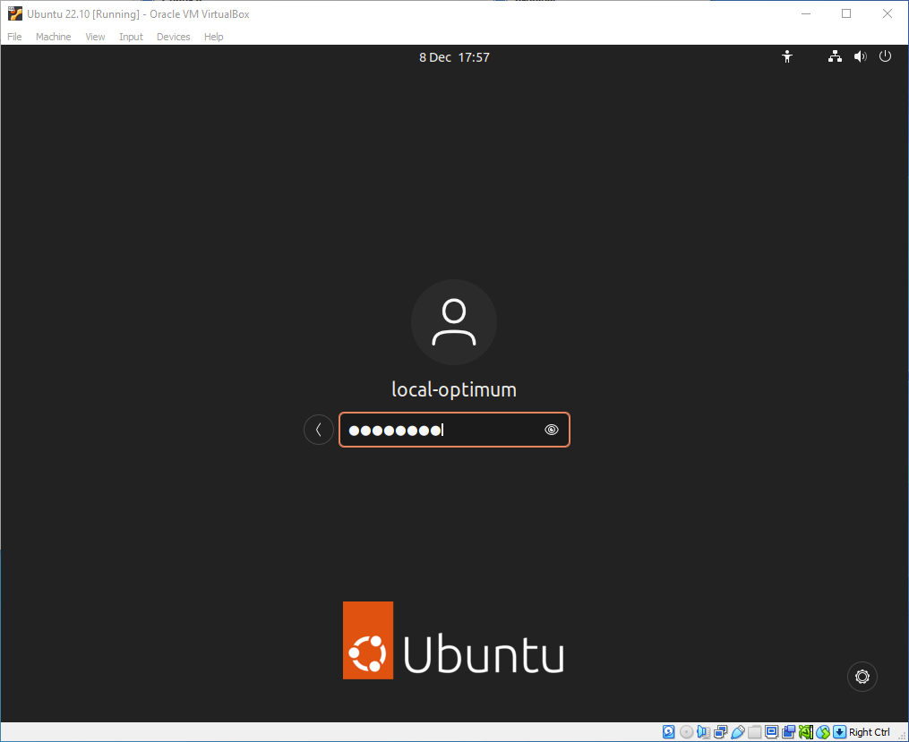

## 4. Explore Virtual Box

Enjoy your shiny new Ubuntu Desktop!

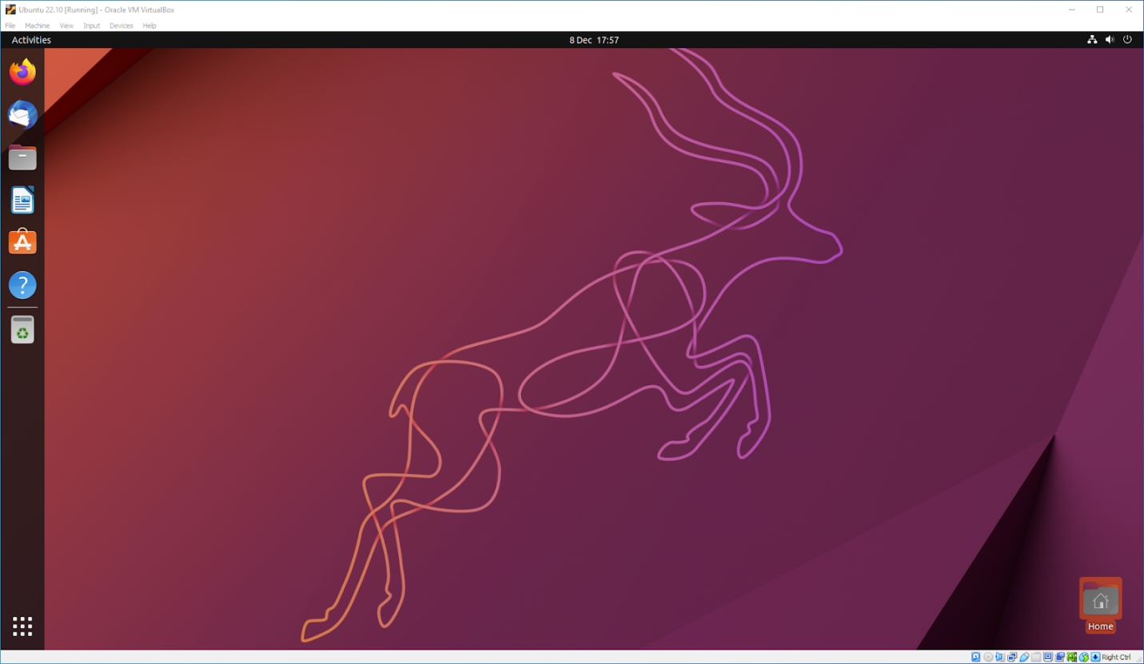

As always we recommend opening a terminal and running sudo apt update && sudo apt upgrade -y and then sudo snap refresh to get everything updated to the latest versions.

Once you’ve finished your session you can close your machine by clicking the **X** in the top right of the window and choosing whether to keep your machine frozen in its current state or shut it down completely.

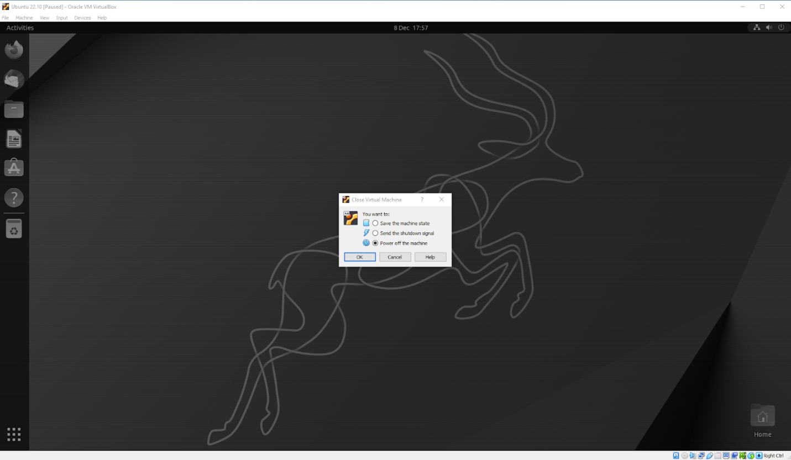

As you can probably tell, there are tonnes of further configuration options available in VirtualBox and we’ve only scratched the surface.

VirtualBox allows you to create and configure multiple virtual machines, so don’t be afraid to create new instances of Ubuntu to try out different system and storage configurations to fine tune your performance.

Why not try following the tutorial above with one of the [Ubuntu flavours](https://ubuntu.com/desktop/flavours)!

[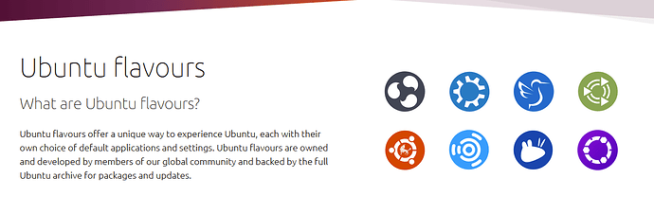](https://ubuntucommunity.s3.dualstack.us-east-2.amazonaws.com/original/3X/1/6/164d32c05935382bf167615a445aa1a74785ee5c.png)

WEEK-2

Client server communication between two virtual machine instances, execution of chat application.

**A hypervisor** is a type of software or hardware used to create virtual machines and then run those virtual machines day to day.

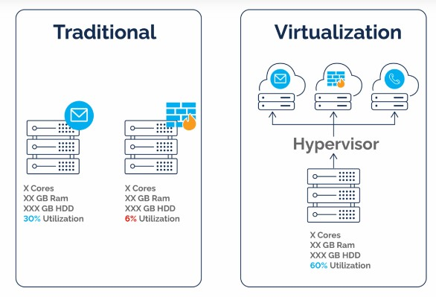

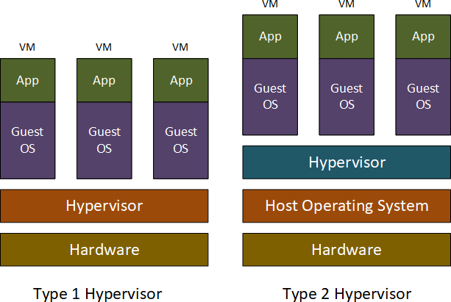

**Enter virtualization**. This technology allows multiple virtual machines to run on one server. Now, a single piece of equipment in the physical world can actually look and act like multiple independent servers in the virtual world.

**A hypervisor** might be hardware, or it could be a program to manage virtual machines, whether software or firmware. A hypervisor is used for—it creates, monitors, and manages virtual machines

# The Role of Hypervisor Technology

The hypervisor is the boss of virtual machines, which we’ll call VMs from here on. The hypervisor allocates resources to VMs or, in other words, manages the physical resources, such as CPU, memory, and storage that execute functions in the VM environments.

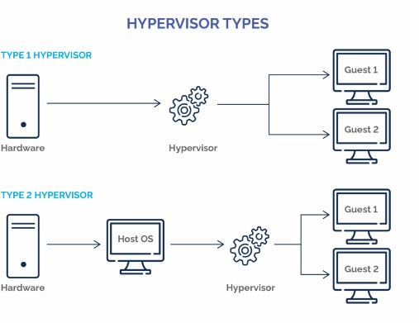

# Type 1 Hypervisor

Most common in enterprise data centers, a type 1 hypervisor replaces the host’s operating system and lies right on top of the hardware. For this reason, type 1 hypervisors are also called bare metal hypervisors or embedded hypervisors.

# Type 1 Hypervisor Examples

Here’s a list of hypervisors of the type 1 variety:

* VMware hypervisors like vSphere, ESXi and ESX
* Microsoft Hyper-V
* Oracle VM Server
* Citrix Hypervisor

# Type 2 Hypervisors

A type 2 hypervisor is hosted, running as software on the O/S, which in turn runs on the physical hardware. This form of hypervisor is typically used to run multiple operating systems on one personal computer, such as to enable the user to boot into either Windows or Linux.

# Type 2 Hypervisor Examples

Type 2 hypervisor examples include:

* VMware Workstation
* VMware Fusion
* Oracle VirtualBox
* Oracle Solaris Zones
* Oracle VM Server for x86

# How Does a Hypervisor Work?

A hypervisor sits between the physical and the virtual. Depending on the type, it might sit right on top of the hardware or it on the O/S. Either way, hypervisors

translate VM requests, which are by definition virtual, for the physical hardware on which the operations must still run.

Imagine you’re a VM in need of CPU, memory, storage space, bandwidth, etc., to perform an operation—ask (the hypervisor) and you shall receive.

# Exp. No:2 Client Server communication between two virtual machine instances, execution of chat application.

**Establish Communication Between Virtual Machines:**

When you create a VM, a virtual network card is allocated by default, allowing it to access the internet. However, you'll have to configure it if it doesn't work automatically.

There are **several** network modes that define how your VM will access the network. The most widely used are:

* + NAT (default mode)
  + Bridged network
  + Internal network
  + NAT network
  + Private host network

# Each network mode is best for:

|  |  |
| --- | --- |
| **Network mode** | Example of when it should be used |
| **NAT** | Only use one VM to download apps, carry out updates, or surf the internet. |
| **Bridged network** | You want your VM to become a web server. It needs to be seen on the network as a physical machine with its own externally accessible IP address. |
| **Internal network** | You are using several VMs to simulate private networks that do not have external access or access to the host machine. |
| **NAT**  **network** | Similar to NAT, several VMs need to communicate with each other (impossible in classic NAT mode). |
| **Private host network** | Similar to an internal network, but when communication needs to be allowed with the host. |

You’re working on a **multi-platform** app for internal use only. The company has Android, Windows, and Linux machines, and you want to check if your app works properly in this complex environment. To function, it needs to be able to:

* + Regularly **send** requests to the other machines.
  + **Retrieve** database updates from a remote server which can be accessed via a URL.

# Connect to the Internet in NAT Mode:

Let's start by looking at an NAT network.

# Step 1: Creating VMs

We’re going to create three VMs:

# Ubuntu

* + **Windows 10**

# Android

There’s no need to create a new Ubuntu or Android VM .

If you have performance problems when you launch all of your VMs simultaneously, it may be because your host system does not have enough RAM or you have not allocated enough to your VMs. Here you are reaching the limits of what is possible with type 2 hypervisors.

# Step 2: Configure the Network NAT Mode

As previously mentioned, the default network mode is NAT. It allows VMs to access the internet (if their host is connected ), but not to communicate with each other.

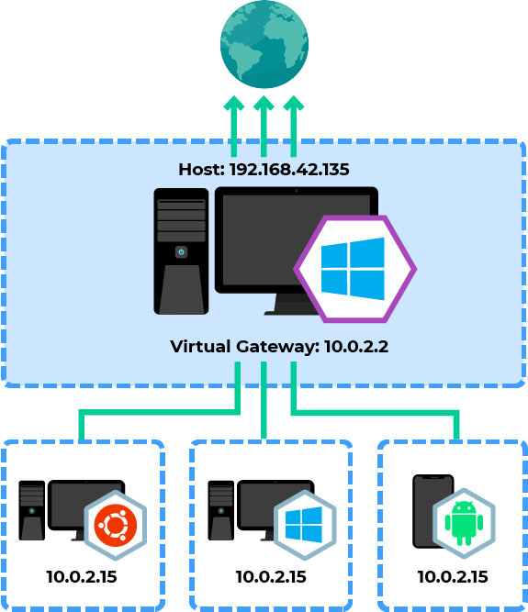

Network Configuration Diagram

You can check this by looking at the IP address given to each VM. Use these instructions to find the IP address of each VM:

1. Windows - open Command Prompt, type **ipconfig**, and hit Enter . You will see the IPv4 address.
2. Ubuntu - open Terminal, type **ifconfig**, and hit Enter . You will see the InetAddress.
3. Android - open Settings and make sure you are connected to

the **VirtWifi** network. Choose Wi-Fi preferences - Advanced - and find the IP address.

It's important that our three VMs have the IP address: **10.0.2.15** and that they can access the internet. This also means that they are on **three different networks** as it is **impossible** to allocate the same IP address to three machines on the same network.

# Internal Network Mode

The simplest way to establish communication between the VMs is to put them all on an internal network using the **internal network** mode.

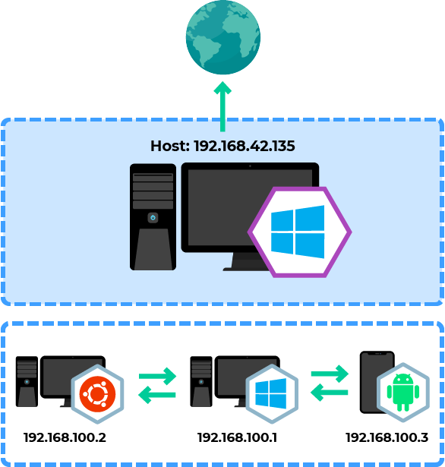

# Set up an internal network

To do this, switch off your VM, and go to the Network configuration section.

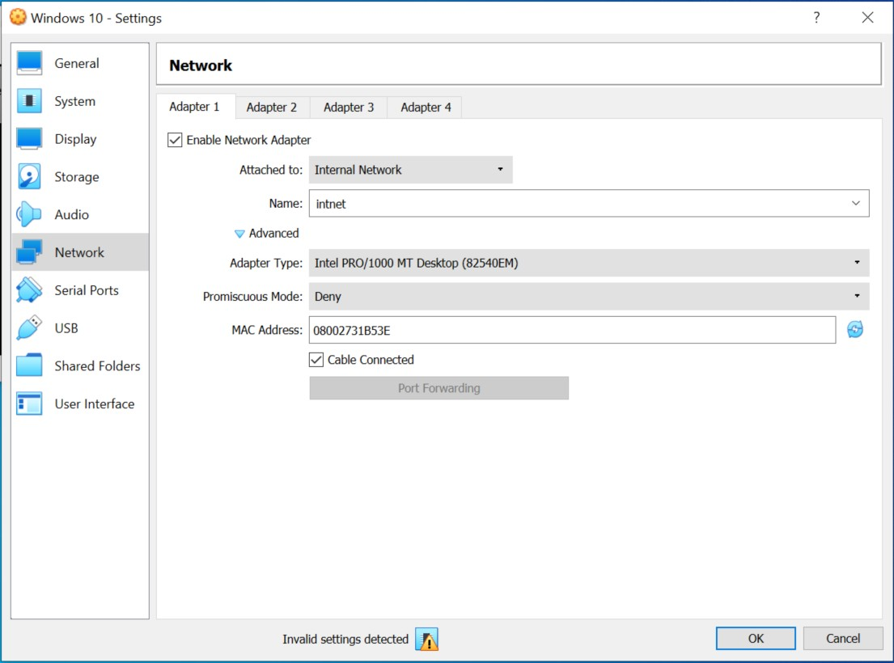

# VM Network settings screen

In **Network access mode**, select **Internal Network**, and either leave the default name or choose another one.

This name sets a tag for the private network, as a VLAN would do. You must enter the same name for each virtual network card if you want your VMs to communicate.

In the **Advanced** section, you’ll see that you can also change certain settings:

* + **Type of card** – The virtual network card model that your VM will see.
  + **Promiscuous mode** – Allows the card to see all packets in transit on the network, not only those intended for it. Only activate this option in very specific cases for network tests.
  + **MAC address** – The MAC address of your virtual network card.

In our case, we don’t need to change these settings.

If you start your VMs now, you’ll see that they have not been allocated an IP address. Although they are on the same network, there is no DHCP server. Therefore, you will have to allocate an IP address manually.

Let’s go through the configuration for the Windows VM (**192.168.100.1**) and the Ubuntu VM (**192.168.100.2**) and check the result with a ping:

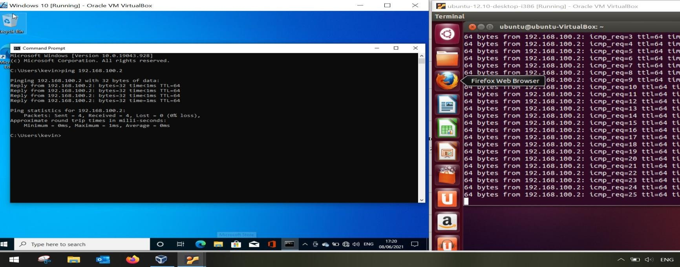

# Using a ping on a Windows and Ubuntu VM

In **internal network** mode, the VMs cannot access the internet and cannot be seen from other networks.

# Setting Up the Internal Network Mode:

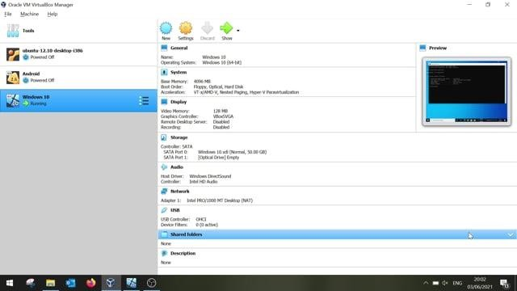

**Bridged Network Mode**

Use bridge network mode if you want to allow your VMs to access the internet, communicate with each other, and be visible externally.

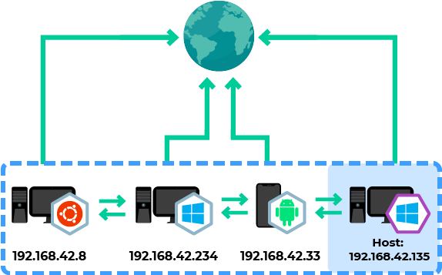

# Bridged network diagram

Go back into the network configuration of each VM when they are powered off and choose **bridged adapter** mode.

You’ll see that you are asked to choose one of the host machine’s network cards. Choose the one that allows your host machine to access the internet.



Then launch your VMs. Once you’ve done this, check that your machine’s operating systems are configured to receive an IP address via DHCP automatically.

Your VMs will automatically receive an IP address on the same network as your host machine.

all of machines are on the network 192.168.1.0/24, including my host machine .

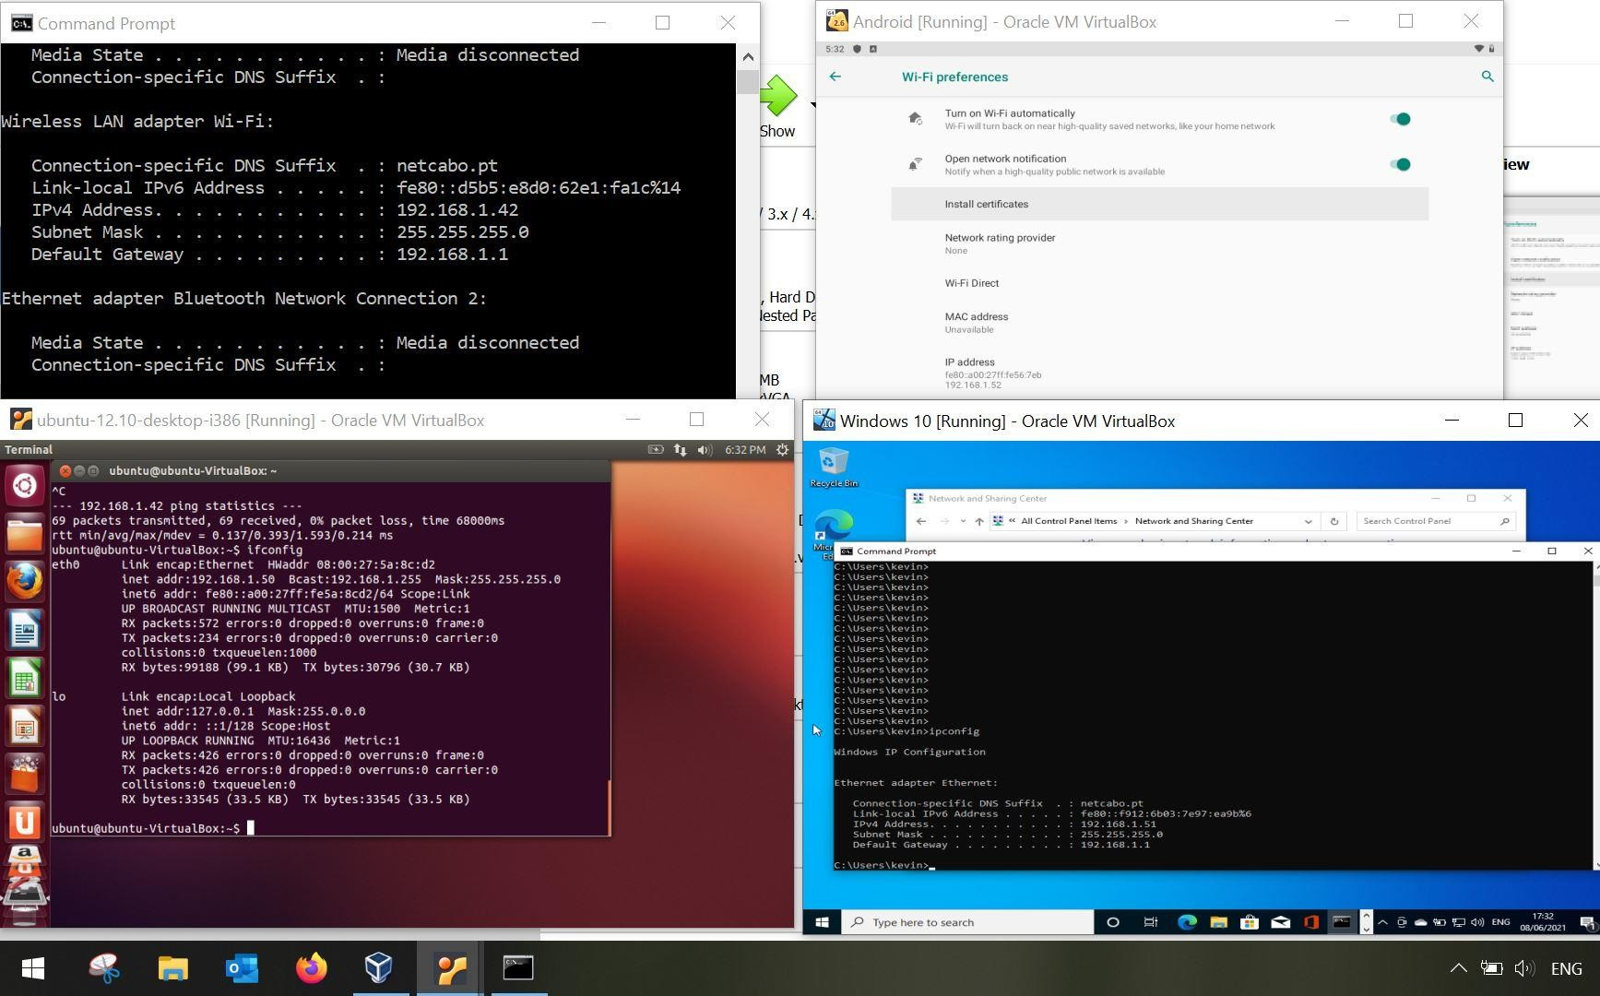

This means that they can all communicate with each other and access the internet.

# Setting Up Bridged Networking

Bridged networking mode is useful in a number of scenarios. Follow along with my video to see how to configure your VMs to use this mode:

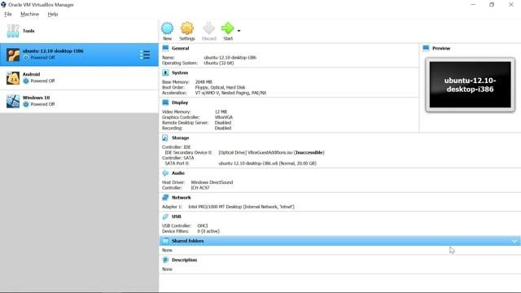

This mode is perfect for our practical example, as it fills **our two requirements**:

* + The app undergoing beta testing must be able to issue requests to all the other machines regularly.
  + The app must **update its database automatically** using a remote server accessible via a URL.

# WEEK 3:

Creation of simple network topology using open-source network virtualization tools (like mininet and others).

# Mininet Introduction:

Commands:

* preceeds Linux commands that should be typed at the shell prompt

|  |  |
| --- | --- |
| **$** |  |
| **mininet>** | |
| **#** |  |

* preceeds Mininet commands that should be typed at Mininet‟s CLI,
* preceeds Linux commands that are typed at a root shell prompt.

# Display Mininet CLI commands:

mininet> help

# command to display a help message describing Mininet’s startup options.

$ sudo mn –h

# Interact with Hosts and Switches

The default topology is the topology, which includes one OpenFlow kernel

**minimal**

switch connected to two hosts, plus the OpenFlow reference controller.

All four entities (2 host processes, 1 switch process, 1 basic controller) are now running in the VM. The controller can be outside the VM, and instructions for that are at the bottom.

Start a minimal topology and enter the CLI:

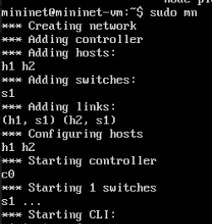$ sudo mn O/P:

* 1. 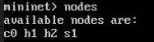**Display nodes:** mininet> nodes O/P:
  2. 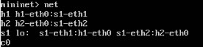**Display links:** mininet> net O/P:

# Dump information about all nodes:

mininet> dump

# Check the switchs and hosts .

mininet> h1 ifconfig -a O/P:

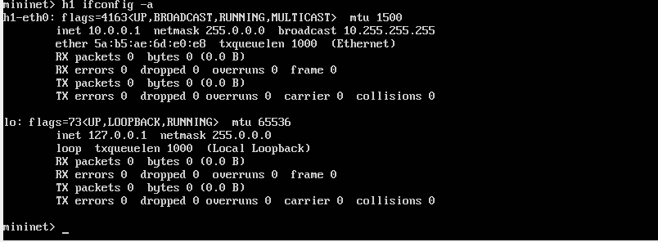

# show the switch interfaces, plus the VM’s connection out (eth1).

It would be possible to place every host, switch and controller in its own isolated network namespace.

mininet> s1 ifconfig -a

* 1. Only the network is virtualized; each host process sees the same set of processes and directories.

# Print the process list from a host process:

mininet> h1 ps –a O/P:

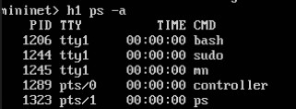

# Print the process list from a switch.

mininet> s1 ps –a

# Test connectivity between hosts

you can ping from host 0 to host 1:

mininet> h1 ping -c 1 h2 O/P:

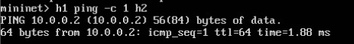

The first host ARPs for the MAC address of the second, which causes

a message to go to the controller. The controller then sends

packet_in

a message to flood the broadcast packet to other ports on the switch (in

packet_out

this example, the only other data port). The second host sees the ARP request and sends a reply. This reply goes to the controller, which sends it to the first host and pushes down a flow entry.

Now the first host knows the MAC address of the second, and can send its ping via an ICMP Echo Request. This request, along with its corresponding reply from the second host, both go the controller and result in a flow entry pushed down.

* 1. lower

ICMP

time for the second try (< 100us). A flow entry covering

traffic was previously installed in the switch, so no control traffic was

**ping**

**ping**

generated, and the packets immediately pass through the switch.

mininet> h1 ping -c 1 h2 O/P:

* 1. **Exit the CLI:** mininet> exit O/P:

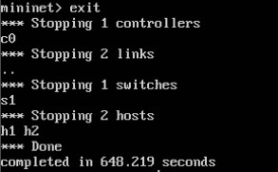

# If Mininet crashes for some reason, clean it up:

$ sudo mn –c

# Python API Examples

example that may be particularly useful to create and run the topology on every host:

# you can change the directory first you check list of files and directories in root .

$ mininet @mininet –vm$ ls

# Then change the mininet directory using CD command.

$ mininet @mininet –vm$ cd mininet

$ mininet @mininet –vm:~/ mininet$

# Check the all list of files and directories using ls command.

$ mininet @mininet –vm:~/ mininet$ ls

# Then change the examples directory using CD command.

$ mininet @mininet –vm:~/ mininet$ cd examples

$ mininet @mininet –vm:~/ mininet /examples$

# Check the all list of files and directories using ls command.

$ mininet @mininet –vm:~/ mininet /examples$ls O/P:

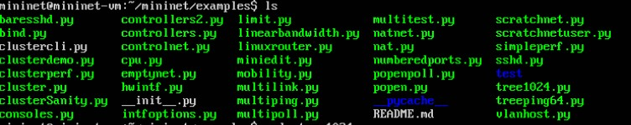

# We get some inbuilt python examples for creation of topology. Display the python code:

$ mininet @mininet –vm:~/ mininet /examples$ vi file name.py

# Run the python code:

$ mininet @mininet –vm:~/ mininet /examples$ sudo python file name.py

# * Example 1: code

From mininet.cli import CLI import CLI From mininet.log import setLogLdevel From mininet.node import OVSSwitch From mininet.topolob import TreeNet

From mininet.examples.treeping64 import HostV4

if name ==‟ main__‟: setLogLevel(„info‟)

network=TreeNet(depth=2 , fanout=32 , host=HostV4 , switch=OVSSwitch ,

waitConnected=True)

network.run( CLI, network )

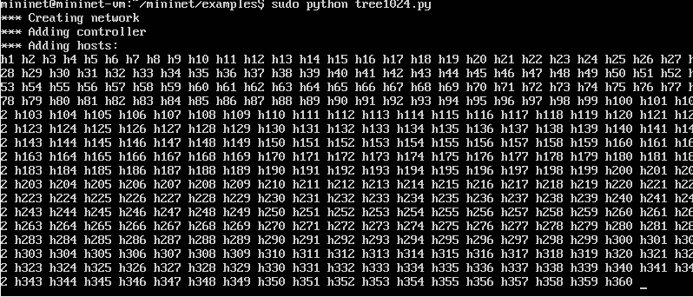O/P:

# * Example 2: code

from mininet.net import Mininet

from mininet.topo import SingleSwitchTopo from mininet.log import setLogLevel , info from mininet.util import pmoniter

def monitorhosts( hosts=5 )

“Start a bunch of pings and monitor them using popen” mutopo = SingleSwitchTopo( hosts )

net = Mininet( topo=mytopo , waitConnected=True ) net.start()

#start a bunch of pings popens = {}

last = net.hosts[ -1 ] for host in net.hosts:

popens[ host ]=host.popen( “ping -c5 %s” %last.IP() ) #Moniter them and print output

for host, line in pmoniter( popens ): if host:

Info(“<%s>: %s”%( host.name, line))

#Done net.stop()

O/P:

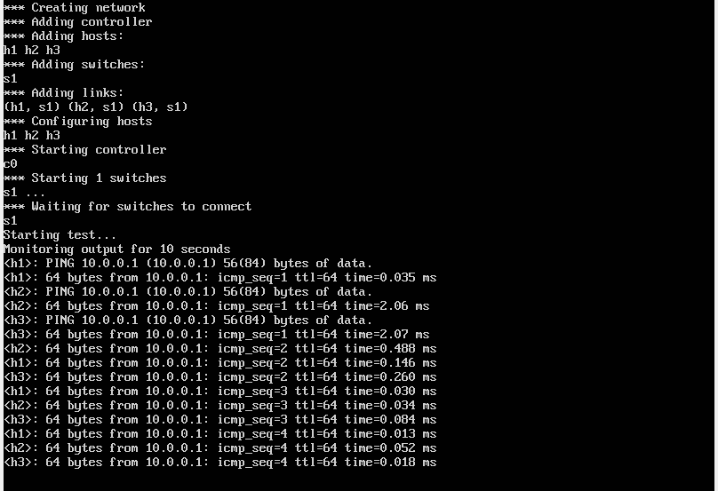

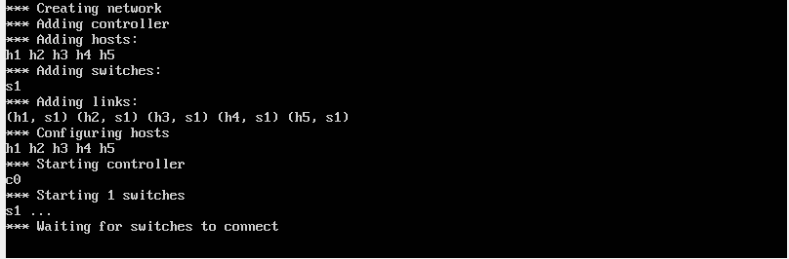

# *Example 3: code

from time import time from signal import SIGINT

from mininet.net import Mininet

from mininet.topo import SingleSwitchTopo from mininet.util import pmonitor

from mininet.log import setLogLevel, info

def pmonitorTest( N=3, seconds=10 ):

“run pings and moniter multiple hosts using pmonitor” topo = SingleSwitchTopo( N )

net = Mininet( topo, waitConnected=True )

net.start()

hosts = net.hosts

info( “Starting test…\n” ) server = hosts[0]

popens = {} for h in hosts:

popens[ h ] = h.popen(„ping‟ , server.IP()) info(“Monitoring output for”, seconds, “seconds\n”) endTime = time()+seconds

for h , line in pmonitor( popens, timeoutms=500): if h:

info( „<%s>:%s‟ %(h.name, line)) if(time()>=endTime:

for p in popens.values(): p.send_signal( SIGINT )

net.stop()

if name == „ main‟: “popenpoll.py”38L,1036C

O/P:

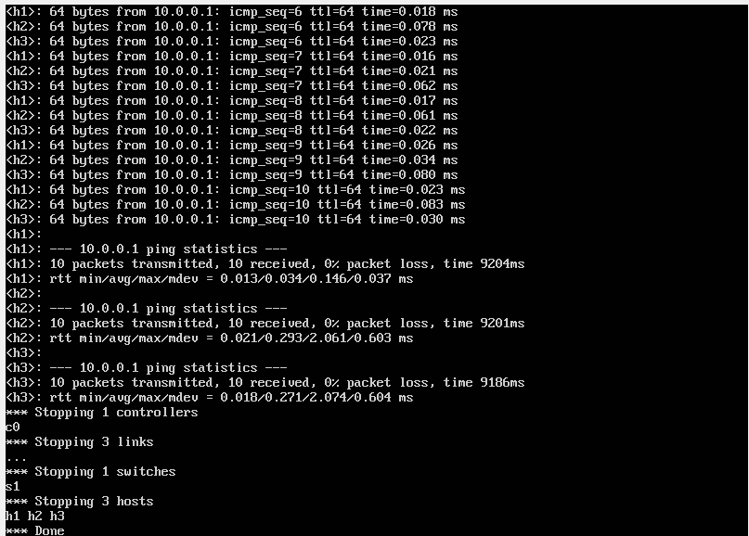

Week 4:

Implementation of various scheduling mechanisms using open-source cloud simulators.

Cloud Simulator:

The key advantages of using a simulation based framework in cloud computing are listed below:

* Simulators facilitate dynamic and flexible configuration and development environments.
* Simulators provide easy-to-use command/graphical interfaces with lots of customisation options that help researchers visualise real world scenarios, thus avoiding all sorts of real-time problems.
* Simulators are the most cost-effective solution for real world implementation.
* Simulators also enable researchers to simulate cloud environments with their own proposed performance, security and other provisioning algorithms.

CLOUD SIMULATION TOOLS:

* + CloudSim
  + CloudAnalyst
  + GreenCloud
  + iCanCloud
  + EMUSIM
  + GroudSim
  + DCSim (Data Centre Simulation)

# CloudSim:

CloudSim is a new, highly generalised and extensible Java based simulation tool kit, and is actually regarded as a software framework. It supports several core functionalities like queuing and processing of events, the creation of CloudSim entities, communication among components and the management of the simulation clock.

Its features are listed below:

* Supports modelling and simulation of large scale cloud computing data centres.
* Supports modelling and simulation of virtualised server hosts, along with customisable policies for provisioning host resources to virtual machines.
* Supports dynamic inclusion of simulation elements, discontinuations and restarts.
* Has support for user defined policies for allocating hosts to virtual machines (VMs).
* Supports the creation of various data center network topologies, message- passing applications and energy-aware computational resources.
* Has the capability to simulate a federated cloud environment that inter-networks resources from both private and public domains.

# CloudAnalyst

CloudAnalyst, a GUI based simulator derived from CloudSim, has some extended features and capabilities. The simulator supports the evaluation of social network tools according to the geographical distribution of users and data centres.

# GreenCloud

GreenCloud provides a simulation environment for energy-aware cloud computing data centres. It is regarded as the most sophisticated packet-level simulator available till date for energy-aware cloud computing data centres, with a focus on cloud communications.

GreenCloud simulator calls a set of the following simulation scripts:

* *setup_params.tcl:* Contains general server configuration, switches, tasks, monitoring and migration.
* *toplogy.tcl:* Creates the data centre network topology.
* *dc.tcl:* Creates data centre servers and VMs.
* *user.tcl:* Defines the behaviour of cloud users.
* *record.tcl:* Sets up runtime results-reporting procedures.
* *finish.tcl:* Calculates and reports simulation statistics.

# iCanCloud

iCanCloud is a cloud computing simulation platform which is based on SIMCAN and supports the simulation of large storage networks.

The features of iCanCloud are listed below:

* + Both existing and non-existing cloud computing architectures can be modelled and simulated.
  + A flexible cloud hypervisor module provides an easy method for integrating and testing both new and existent cloud brokering policies.
  + Customisable VMs can be used to quickly simulate uni-core/multi-core systems.
  + iCanCloud provides a wide range of configurations for storage systems, which include models for local storage systems, remote storage systems like NFS, and parallel storage systems (like parallel file systems and RAID systems).

# EMUSIM

EMUSIM stands for Integrated Emulation and Simulation. It combines emulation (AEF-Automated Emulation Framework) and Simulation (CloudSim) to enable more accurate models of software artefacts to be used during simulations.

The features of EMUSIM are listed below:

* + Offers a combination of simulation and emulation to evaluate the effect of varying resources and patterns of requests on cloud applications.
  + Accurately models applications to supply information regarding performance.
  + Supports loosely coupled CPU-intensive applications.

# GroudSim

* + GroudSim (Gr-Grid oud-Cloud) is an event-based simulator designed for scientific applications on grid and cloud environments.

The features of GroudSim are listed below:

* It is a powerful Java based simulation tool kit for scientific applications. It combines grid and cloud infrastructures, and is based on a discrete-event simulation tool kit.
* Improvised performance as compared to process based approaches in other simulators.
* Can be extended easily by adopting probability distribution packages.

# DCSim (Data Centre Simulation)

DCSim is regarded as an extensible data centre simulator designed in Java. It provides a stable and easy framework for developing and performing high- end experiments on data centre management techniques and algorithms. DCSim, being an event-driven simulator, simulates a data centre IaaS offering to multiple clients.

DCSim provides the additional capability of modelling replicated VMs, sharing incoming workloads as well as dependencies between VMs that are part of a multi- tieredapplication.

The features of DCSim are listed below:

* + Contains a multi-tier application model that allows the simulation of dependencies between VMs.
  + Facilitates rapid development, evaluation and feedback on data centre management policies and algorithms.

# Installation of CloudSim using Eclipse:

**Setting up the Prerequisites**

* + 1. First of all we need to download the CloudSim (cloudsim-3.0.3) and latest version of the Java Development Toolkit (JDK).
    2. Download and Install the Eclipse from the official web page.

1. CloudSim requires a working Java installation. So, Install the Java latest version in windows.
2. Apache Commons Math provides a faster, more accurate, portable alternative to the regular Math and StrictMathclasses for large scale computation.

FastMath is a drop-in replacement for both Math and StrictMath. This means that for any method in Math (say Math.sin(x) or Math.cbrt(y)), user can directly change the class and use the methods as is

(using FastMath.sin(x) or FastMath.cbrt(y) in the previous example).

1. Install Common-math 4-4.0-beta1-bin form the apache official apache web page.

Here we have 2 binaries file [commons-math4-4.0-beta1-bin.tar.gz](https://dlcdn.apache.org/commons/math/binaries/commons-math4-4.0-beta1-bin.tar.gz) [commons-math4-4.0-beta1-bin.zip](https://dlcdn.apache.org/commons/math/binaries/commons-math4-4.0-beta1-bin.zip)

1. Select the [commons-math4-4.0-beta1-bin.zip](https://dlcdn.apache.org/commons/math/binaries/commons-math4-4.0-beta1-bin.zip) and download it and extract all the files in specified folder (downloads).
2. Open the commons-math 4-4.0-beta1-bin folder and select and copy the commons-math4-core-4.0-beta1 jar file and past it in a commons-math 4- 4.0-beta1-bin folder.

7.

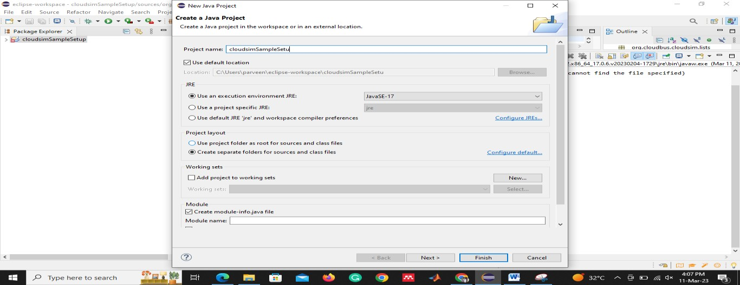

1. Change the “ Use default location” So, browse the specific folder cloudsim-3.0.3 folder.

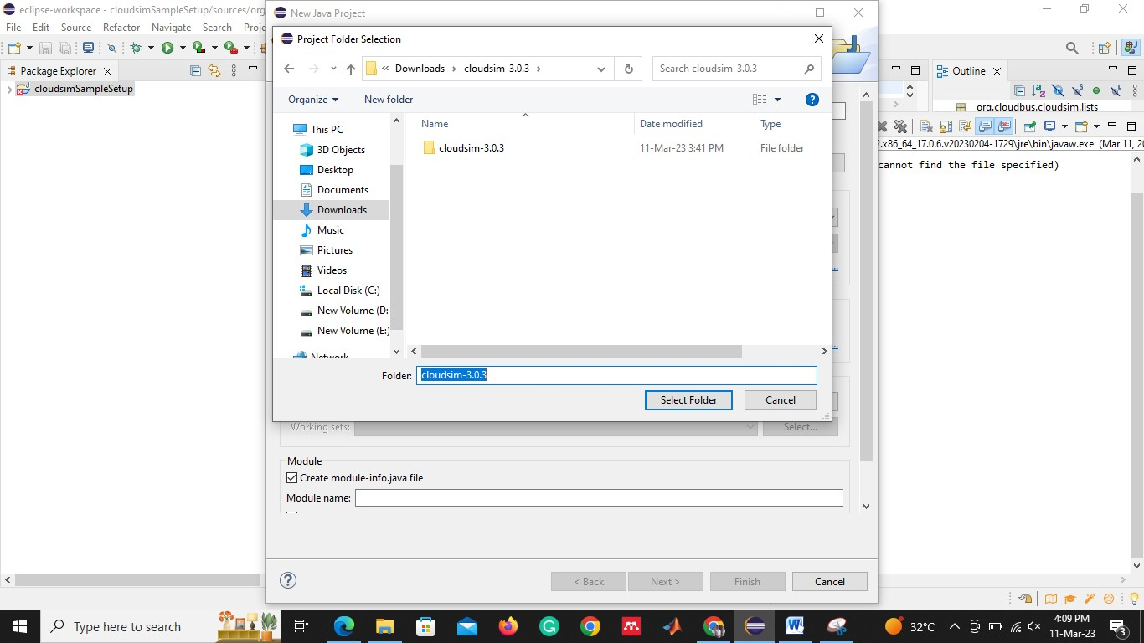

1. Select the next button and get some source files.

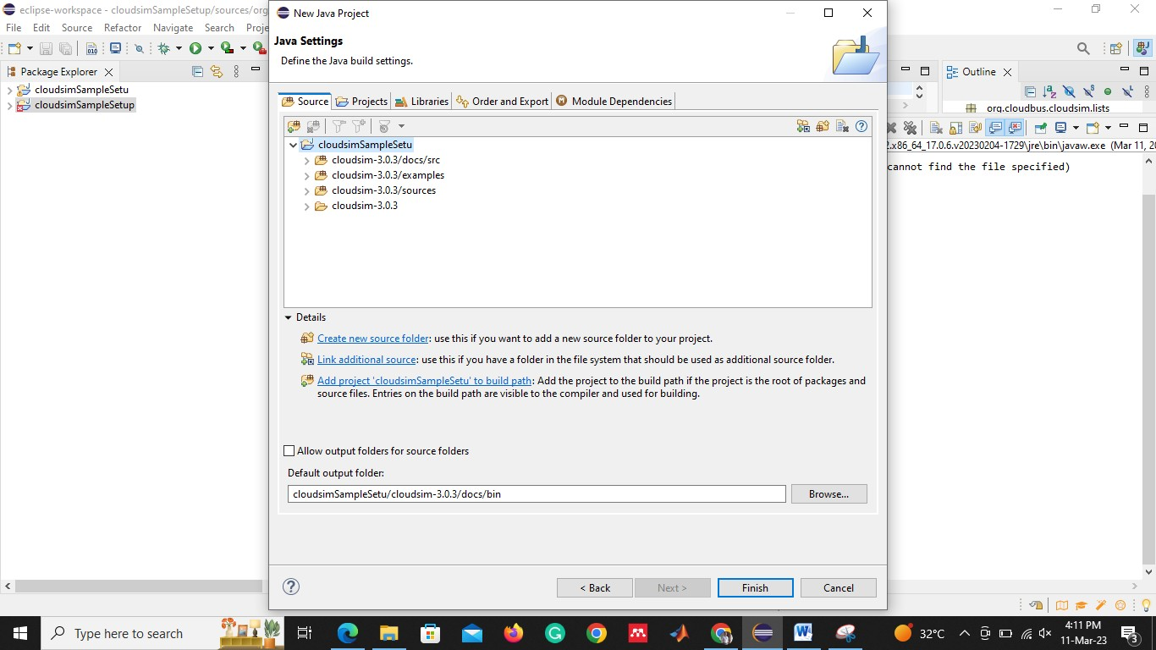

1. Select the “Libraries” tab after project tab. And add external JARs from our system.

Select the common-math 4-4.0-beta1-bin folder, in that we select the Jar file . “commons-math4-core-4.0-beta1”

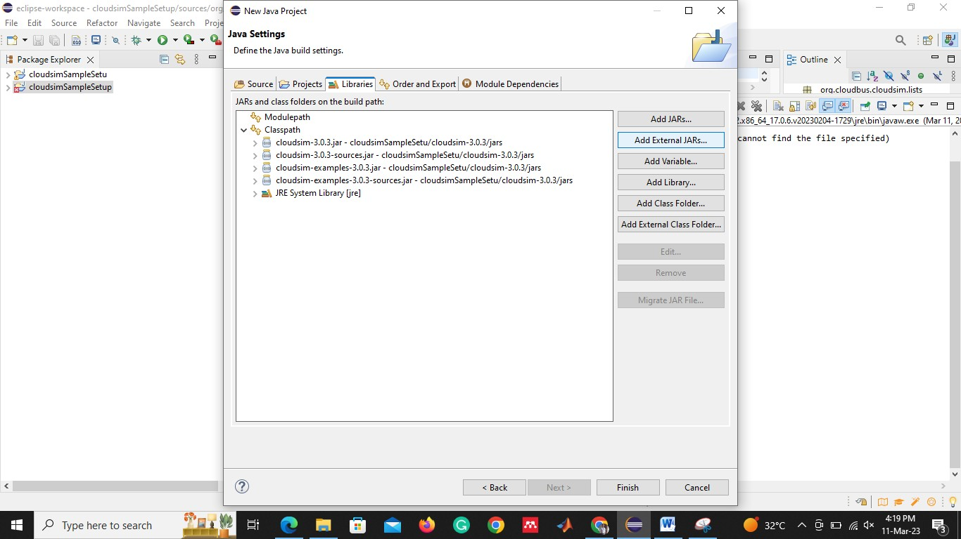

1. Select the finish button. Go to eclipse and select the “Package Explorer” tab. In that select the cloudsim/examples.network and run the any example java file.
2. we get some error and warning to run the java file. So we need to change the compiler settings.

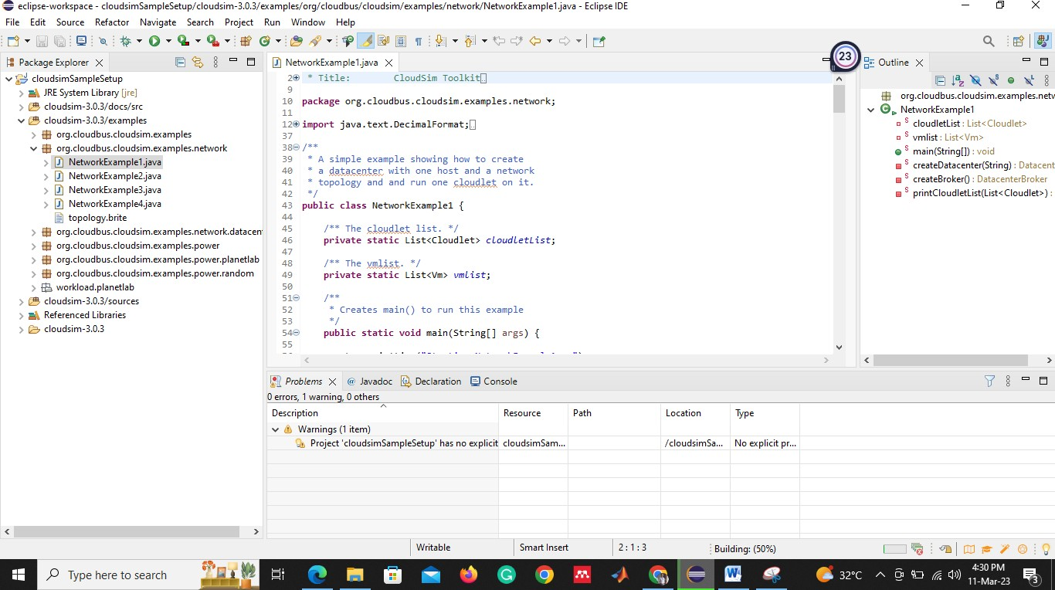

1. Select the CloudsimSampleSetup package properties from “Package Explore” .

We need to change the java compiler – “Enable project specific settings” marked. And press the apply close button.

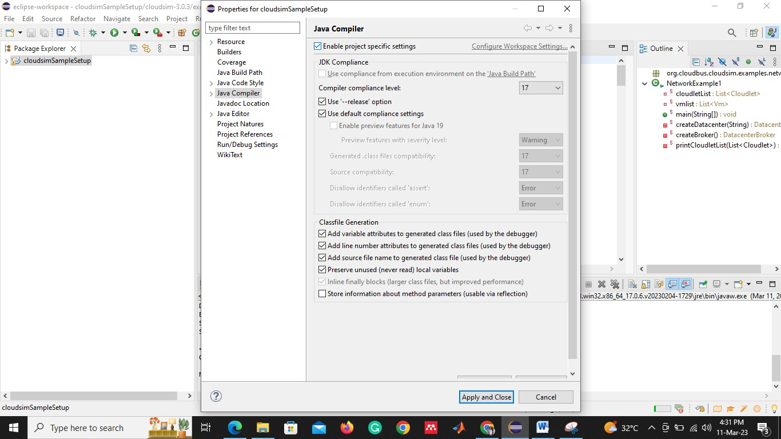

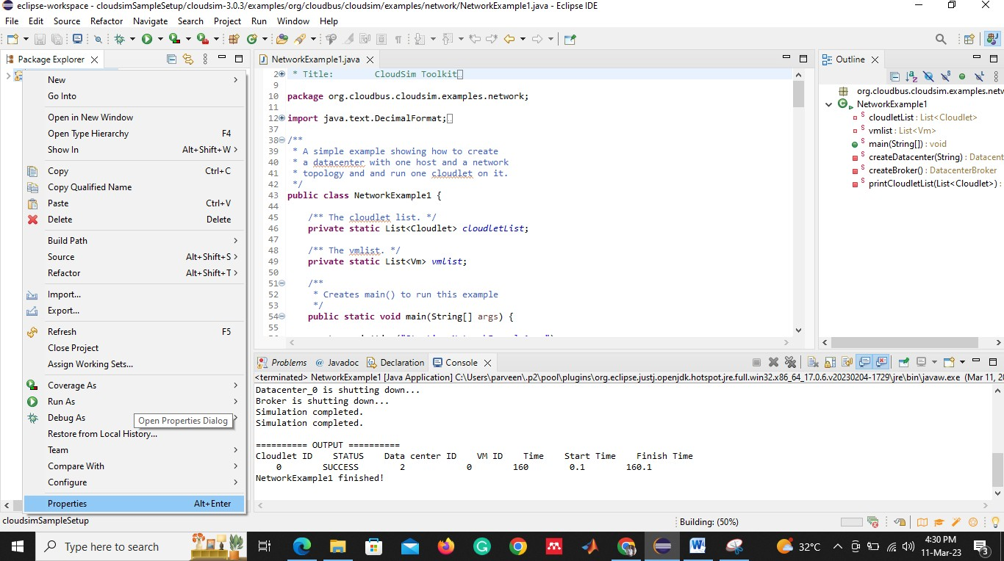

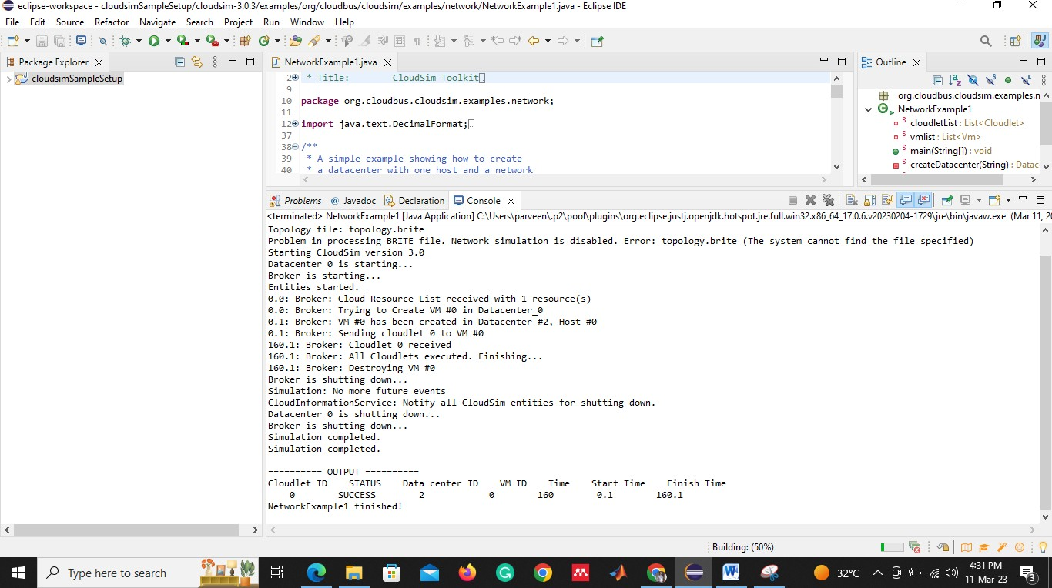

1. Run the java program and observe the outputs.

### Week 5 Open Nebula

### Step 1: Deploying the OVA

Log in to your vCenter installation and select the appropriate datacenter and cluster where you want to deploy the appliance.

Select the name, folder, and a compute resource where you want vOneCloud to be deployed. Also, you’ll need to select the datastore in which to copy the OVA.

Select the network. You will need to choose a network that has access to the ESX hosts.

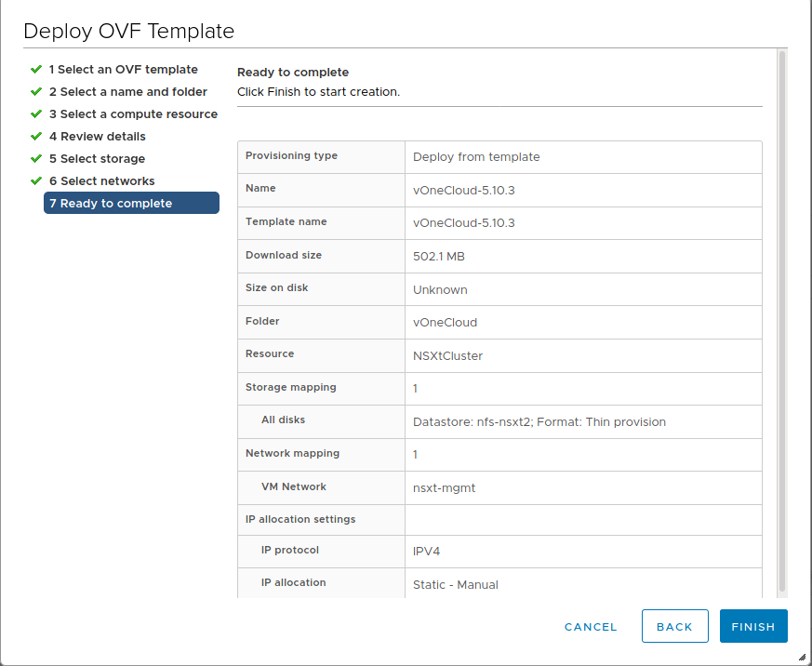

### Step 2: vOneCloud Control Console - Initial Configuration

* “Edit a connection”
* Select “System eth0”
* Change IPv4 CONFIGURATION from <Automatic> to <Manual> and select “Show”
* Input the desired IP address/24 in Addresses
* Input Gateway and DNS Servers
* Select OK and then quit the dialog

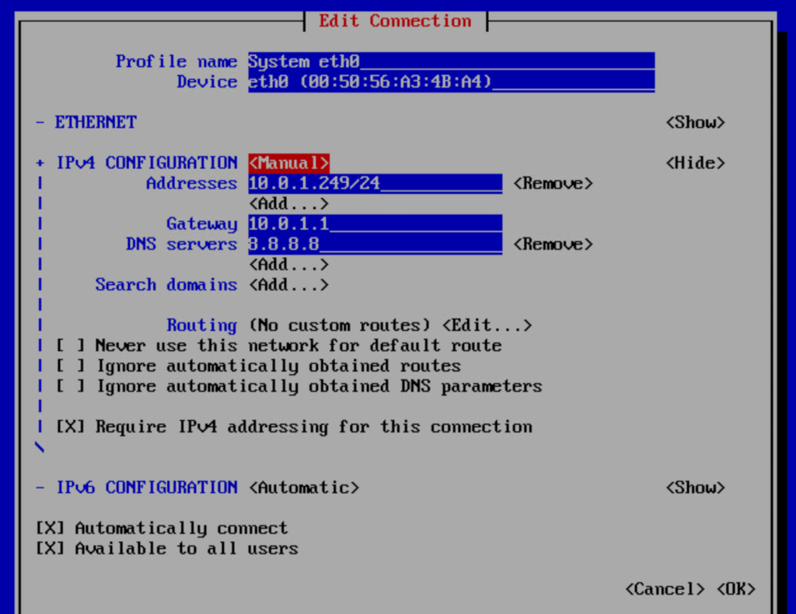

### Step 3: Check access to the Sunstone GUI

After opening the Sunstone interface (http://<appliance_ip> with oneadmin credentials), you are now ready to add computing clusters to OpenNebula and start launching your first Virtual Machines.

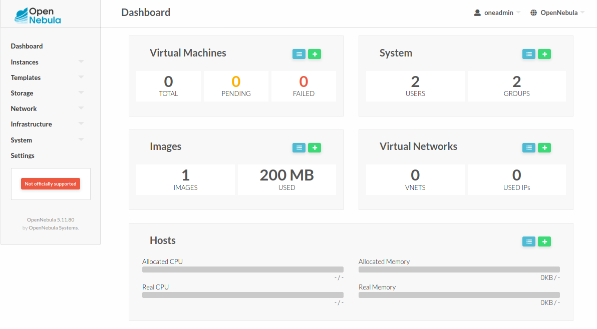

**NEXT STEPS:**

### Step 1: Sunstone login

Log in to Sunstone as **oneadmin.**

### Step 2: Import vCenter Cluster

To import new vCenter clusters to be managed in OpenNebula, proceed in Sunstone to the Infrastructure --> Hosts tab and click on the “+” green icon.

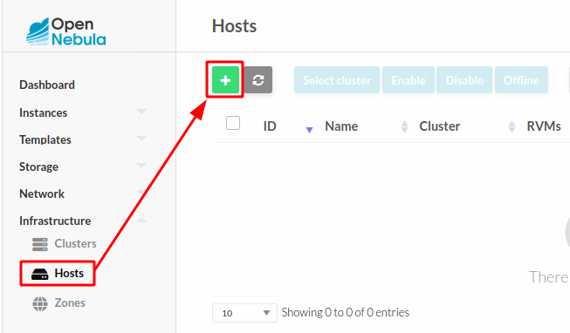

### Step 3: Import Datastores

Datastores can be imported from the Storage --> Datastores Since datastores are going to be used to hold the images from VM Templates, all datastores **must** be imported before VM Template import.

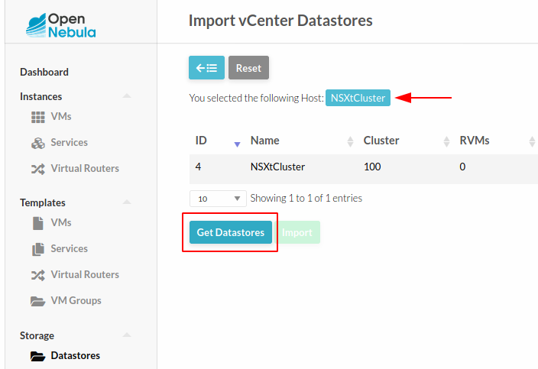

### Step 4: Import Networks

Select the Host and click on “Get Networks”. Select the Network and click on Import. After importing you should see a message indicating that the network was successfully imported.

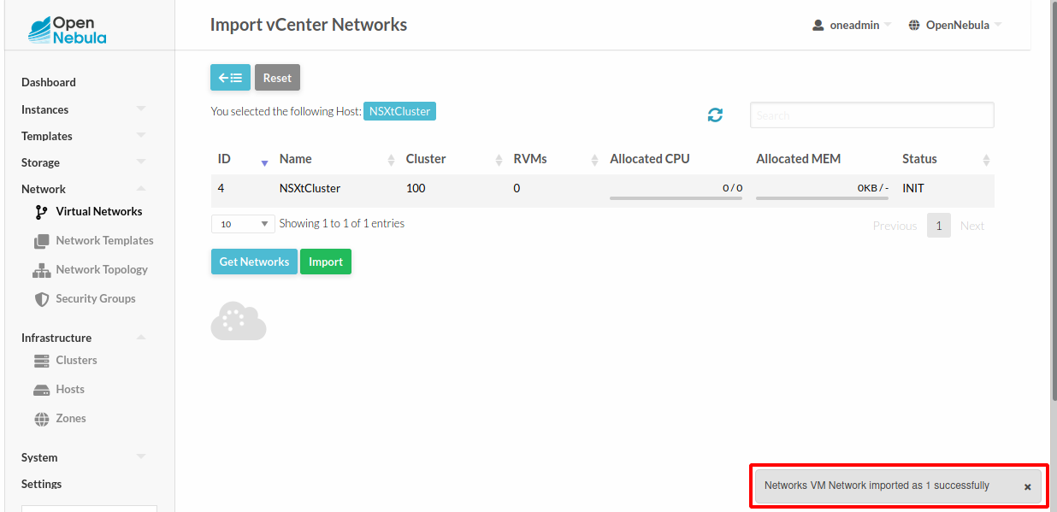

### Step 5: Import VM Templates

vCenter **VM Templates** can be imported and reacquired using the Import button in Templates --> VMs.

Select the Host and click on “Get Templates”. Select the template to import and click on “Import”.

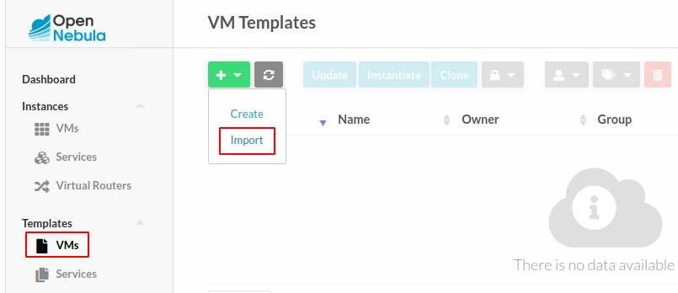

### Step 6: Verification - Launch a VM

Go to your Instances -> VMs tab in Sunstone and click on the “+” green icon. Select the VM Template imported in the previous step (feel free to change any configuration aspect) and click on Create.

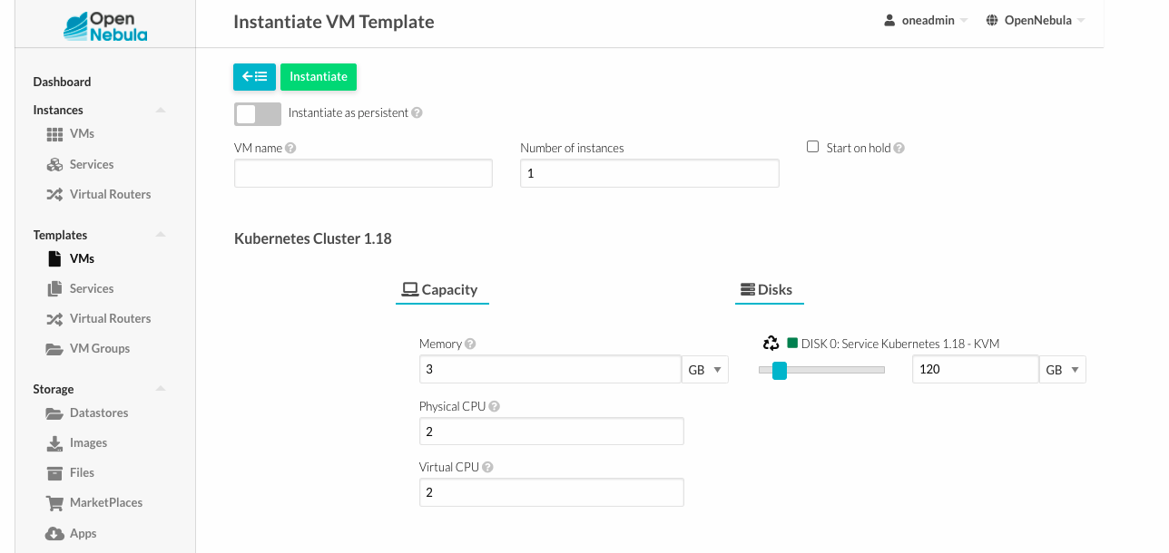

                                                                             WEEK-5

OPEN STACK

OpenStack is an open-source cloud computing platform that provides a complete infrastructure-as-a-service (IaaS) solution for building private, public, and hybrid clouds. It was first released in 2010 by NASA and Rackspace, and has since become one of the most widely used cloud platforms in the world.

Usage: OpenStack provides a comprehensive suite of services that enable organizations to build and manage private and public clouds. Some of the key services included in OpenStack are:

1. Compute (Nova): Compute is OpenStack's virtualization service, which provides a way to create and manage virtual machines (VMs) on a cloud infrastructure.
2. Networking (Neutron): Networking provides virtualized network services that allow users to create and manage virtual networks, routers, and load balancers.
3. Storage (Cinder, Swift): Storage provides block storage (Cinder) and object storage (Swift) services for storing and retrieving data in the cloud.
4. Identity (Keystone): Identity provides authentication and authorization services for OpenStack, allowing users and services to securely access cloud resources.
5. Dashboard (Horizon): Dashboard is OpenStack's web-based interface that provides a unified view of all the services and resources in the cloud.

Advantages:

1. Open-source: OpenStack is open-source software, which means that it is freely available for download, modification, and distribution.
2. Modular architecture: OpenStack's modular architecture allows users to pick and choose which services they want to use, and customize them to meet their specific needs.
3. Scalability: OpenStack is designed to be highly scalable, allowing users to add and remove resources as needed to meet changing demands.
4. Multi-cloud support: OpenStack can be used to build private, public, and hybrid clouds, and can integrate with a wide range of public cloud providers like AWS, Azure, and Google Cloud.
5. Large community: OpenStack has a large and active community of developers and users, which means that there is a lot of support and resources available for users.

Disadvantages:

1. Complexity: OpenStack is a complex platform that requires a lot of expertise and resources to deploy and manage.
2. Steep learning curve: Because OpenStack is a complex platform, there is a steep learning curve for new users who want to get started with it.
3. Integration issues: OpenStack can be difficult to integrate with other systems and tools, which can make it challenging to use in some environments.
4. Hardware requirements: OpenStack requires a lot of hardware resources to run effectively, which can make it expensive to deploy and manage.

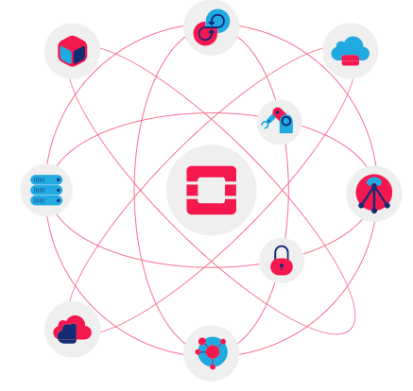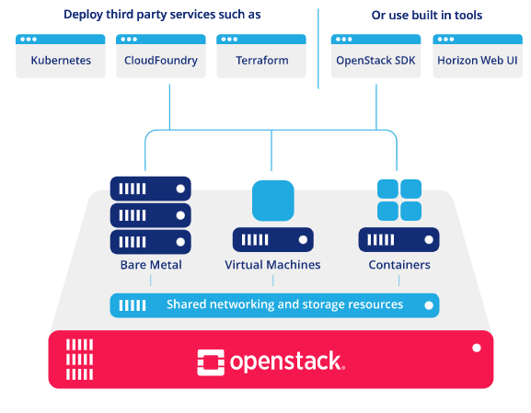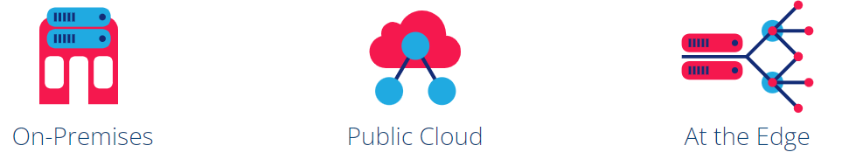

OPEN NEBULA

OpenNebula is an open-source cloud computing platform that provides a simple, flexible, and scalable solution for building private and hybrid clouds. It was first released in 2008 by OpenNebula Systems, and has since become a popular cloud platform used by organizations of all sizes.

Usage: OpenNebula provides a range of services that enable organizations to build and manage private and hybrid clouds. Some of the key services included in OpenNebula are:

1. Virtualization (KVM, VMware, Xen): OpenNebula supports multiple hypervisors, including KVM, VMware, and Xen, which enables organizations to use their existing virtualization technologies.
2. Networking: OpenNebula provides a virtual network infrastructure that allows users to create and manage virtual networks, routers, and load balancers.
3. Storage: OpenNebula provides a range of storage solutions, including local disks, network-attached storage (NAS), and storage area networks (SANs).
4. User management: OpenNebula provides a way to manage users, groups, and permissions, allowing organizations to control access to cloud resources.
5. Dashboard: OpenNebula's web-based interface provides a unified view of all the services and resources in the cloud.

Advantages:

1. Open-source: OpenNebula is open-source software, which means that it is freely available for download, modification, and distribution.
2. Simple and easy to use: OpenNebula is designed to be simple and easy to use, with a user-friendly interface and intuitive workflows.
3. Scalability: OpenNebula is designed to be highly scalable, allowing organizations to add and remove resources as needed to meet changing demands.
4. Hybrid cloud support: OpenNebula supports hybrid cloud environments, allowing organizations to integrate their private cloud with public cloud providers like AWS.
5. Community support: OpenNebula has a large and active community of developers and users, which means that there is a lot of support and resources available for users.

Disadvantages:

1. Limited feature set: OpenNebula's feature set is more limited compared to other cloud platforms like OpenStack or AWS, which may not meet the needs of some organizations.
2. Small user base: While OpenNebula has a dedicated user base, it is not as widely used as other cloud platforms, which can limit the availability of third-party tools and integrations.
3. Customization limitations: OpenNebula's simple design may limit the ability to customize and extend the platform to meet specific needs or use cases.
4. Documentation: OpenNebula's documentation is not as comprehensive compared to other cloud platforms, which can make it more difficult for new users to get started with the platform.

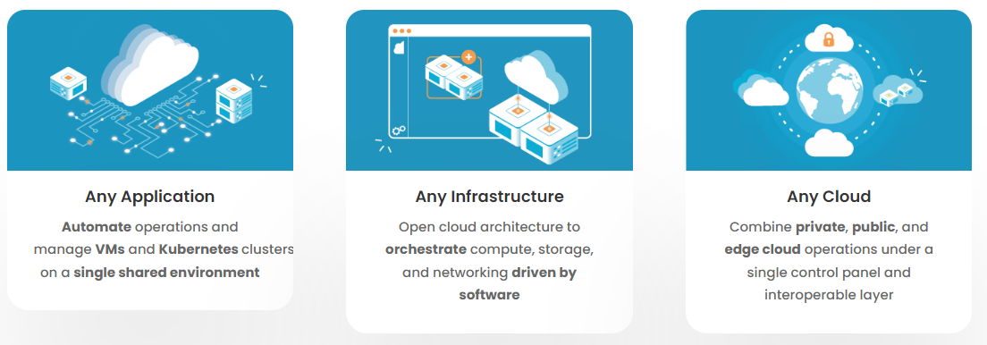

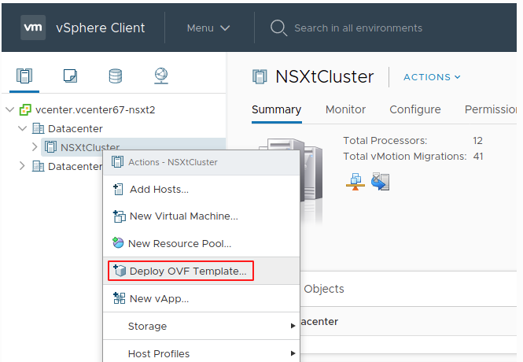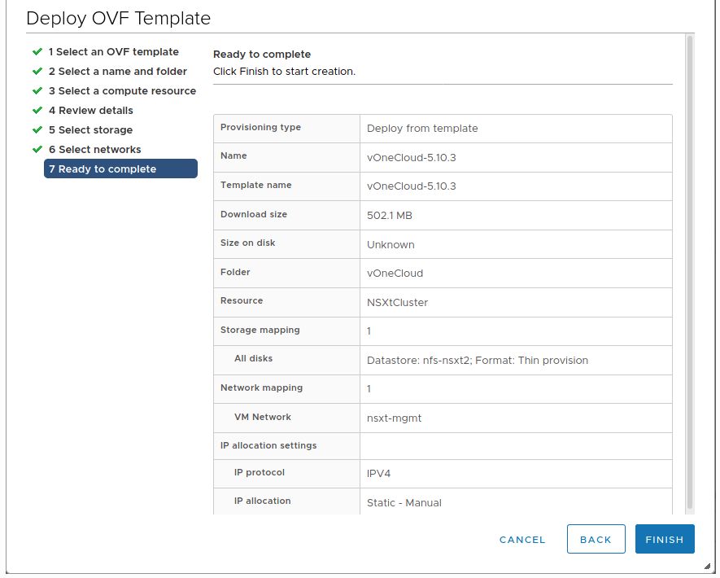

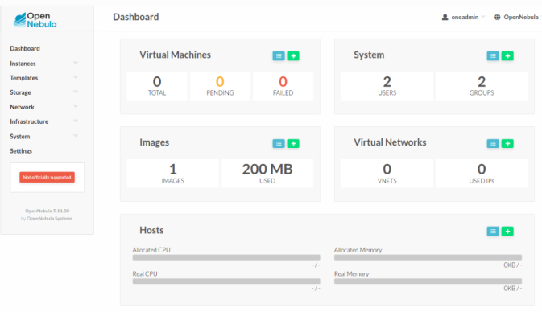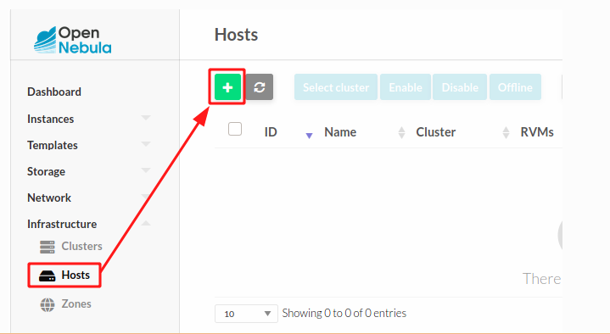

EUCALYPTUS

Eucalyptus is an open-source cloud computing platform that provides a private cloud infrastructure compatible with Amazon Web Services (AWS) APIs. It was first released in 2008 by a team of researchers at the University of California, Santa Barbara, and has since become a popular cloud platform used by many organizations.

Usage: Eucalyptus provides a range of services that enable organizations to build and manage private clouds that are compatible with AWS. Some of the key services included in Eucalyptus are:

1. Virtualization (KVM, Xen): Eucalyptus supports multiple hypervisors, including KVM and Xen, which enables organizations to use their existing virtualization technologies.
2. Networking: Eucalyptus provides a virtual network infrastructure that allows users to create and manage virtual networks, routers, and load balancers.
3. Storage: Eucalyptus provides a range of storage solutions, including local disks, network-attached storage (NAS), and storage area networks (SANs).
4. User management: Eucalyptus provides a way to manage users, groups, and permissions, allowing organizations to control access to cloud resources.
5. Dashboard: Eucalyptus's web-based interface provides a unified view of all the services and resources in the cloud.

Advantages:

1. Compatibility with AWS APIs: Eucalyptus is designed to be compatible with AWS APIs, which means that applications developed for AWS can be run on Eucalyptus without modification.
2. Open-source: Eucalyptus is open-source software, which means that it is freely available for download, modification, and distribution.
3. Simple and easy to use: Eucalyptus is designed to be simple and easy to use, with a user-friendly interface and intuitive workflows.
4. Hybrid cloud support: Eucalyptus supports hybrid cloud environments, allowing organizations to integrate their private cloud with public cloud providers like AWS.
5. Community support: Eucalyptus has a large and active community of developers and users, which means that there is a lot of support and resources available for users.

Disadvantages:

1. Limited feature set: Eucalyptus's feature set is more limited compared to other cloud platforms like OpenStack or AWS, which may not meet the needs of some organizations.
2. Small user base: While Eucalyptus has a dedicated user base, it is not as widely used as other cloud platforms, which can limit the availability of third-party tools and integrations.
3. Customization limitations: Eucalyptus's simple design may limit the ability to customize and extend the platform to meet specific needs or use cases.
4. Vendor lock-in: While Eucalyptus is compatible with AWS APIs, organizations may still be locked into using Eucalyptus as their cloud platform, which can limit flexibility and increase costs.

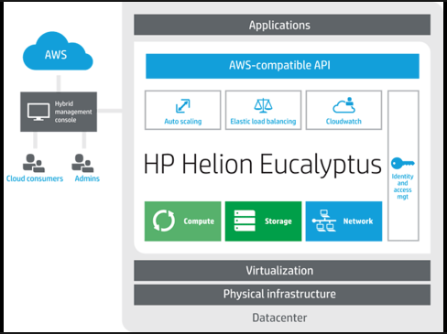

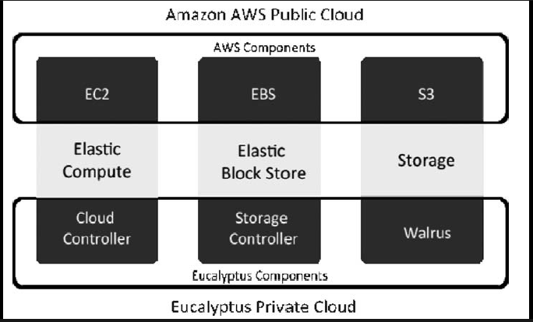

### Cloud Computing Week - 6

**SOFTWARE AS A SERVICE**

### What is software as a service?

Software as a service (SaaS) is a software distribution model in which a cloud provider hosts applications and makes them available to end users over the internet

### How does software as a service work?

SaaS works through the cloud delivery model. A software provider will either host the application and related data using its own servers, databases, networking and computing resources,

SaaS products may be primarily marketed to B2B, B2C markets or both. Examples of popular SaaS products include:

* Salesforce
* Google Workspace apps
* Microsoft 365
* HubSpot
* Trello
* Netflix
* Zoom

**Google Workspace Apps**

Google Workspace is a Software as a Service (SaaS) platform. This means that instead of installing software on your computer, you access the applications through the internet. It includes apps such as Gmail, Google Drive, Google Docs, Google Sheets, Google Slides, Google Meet, and many more.

Here is a brief overview of some of the most popular apps in Google Workspace:

1. Gmail
2. Google Classroom
3. Google Drive
4. Google Docs
5. Google Sheets
6. Google Sites
7. Google Slides
8. Google Meet
9. Google Forms etc.

**Google Classroom**

Google Classroom uses cloud services in several ways:

1. Data storage: Google Classroom stores all course materials, assignments, and student work on Google Drive, a cloud-based storage service. This allows teachers and students to access course materials and assignments from anywhere with an internet connection.
2. Collaboration: Google Classroom is designed to facilitate collaboration between teachers and students.
3. Communication: Google Classroom enables teachers to communicate with students through a variety of cloud-based tools, including email, instant messaging, and video conferencing using Google Meet.
4. Automatic updates: Google Classroom is a cloud-based application, which means that updates are automatically applied to the system. Teachers and students do not need to download and install updates themselves.

Overall, Google Classroom uses cloud services to provide a seamless and collaborative learning environment that is accessible from anywhere with an internet connection.

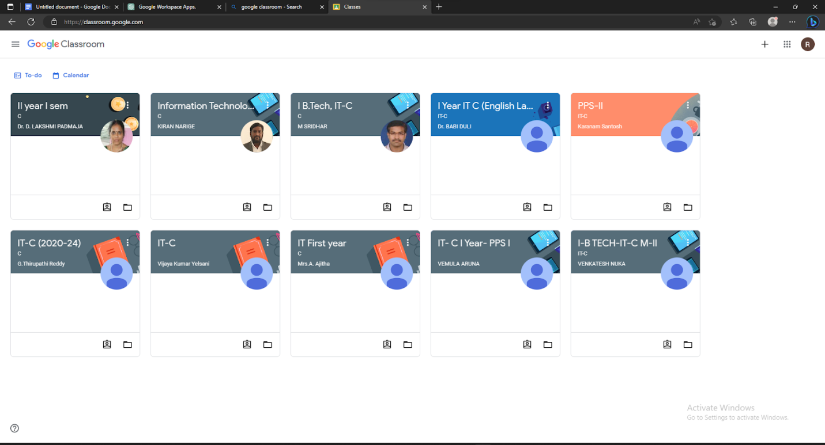

**Google Docs**

**Google Docs is a software as a service (SaaS) application**.

* With Google Docs, users can create and edit documents, spreadsheets, and presentations entirely within a web browser, without the need to download or install any software on their local computer.
* The user data is stored on Google's servers, and users can access their documents from any device with internet access.
* As a SaaS application, Google Docs provides a convenient and flexible way for users to work collaboratively and share documents in real-time.

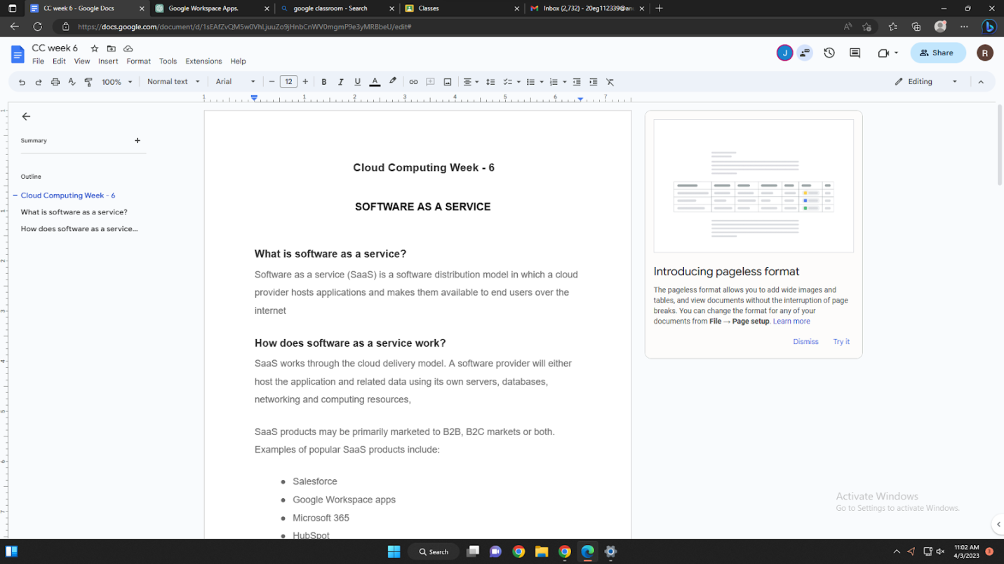

**Google Sites**

Google Sites is a software as a service (SaaS) application.

* Google Sites is a web-based website creation tool that allows users to create and publish websites without coding or web development skills.
* The user data is stored on Google's servers, and users can access and edit their sites from any device with internet access.
* As a SaaS application, Google Sites provides a convenient and flexible way for users to create and publish websites without the need to download or install any software on their local computer.

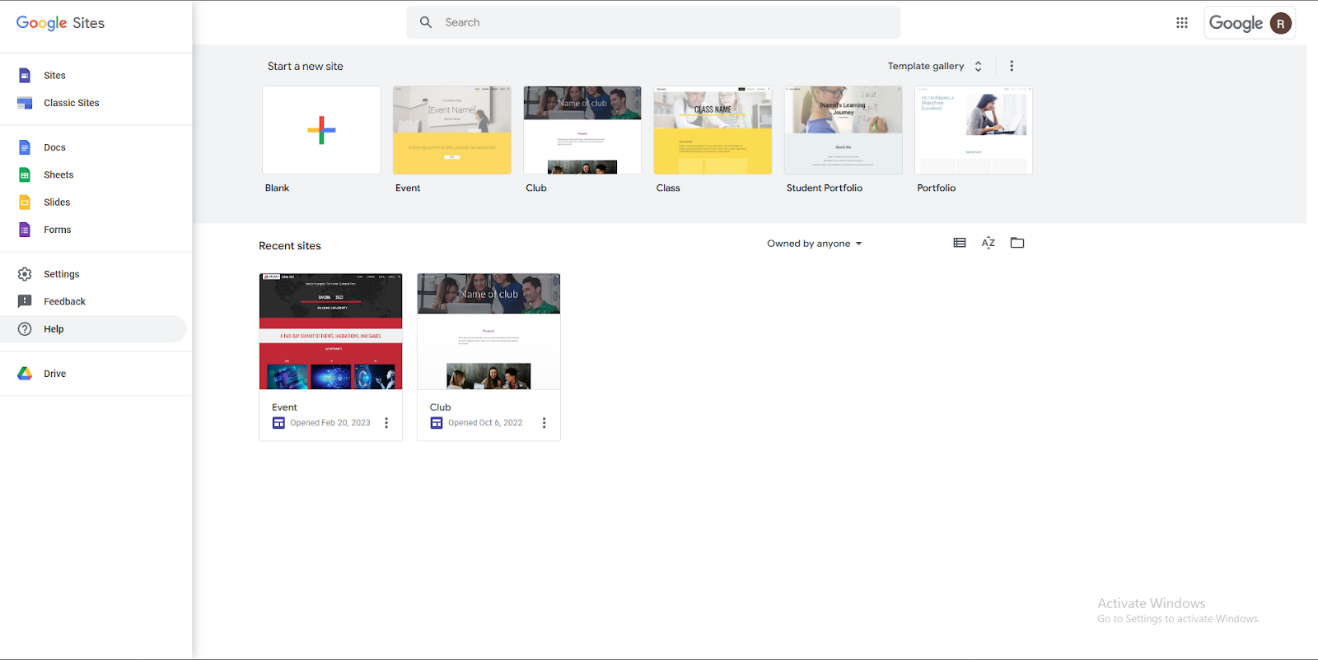

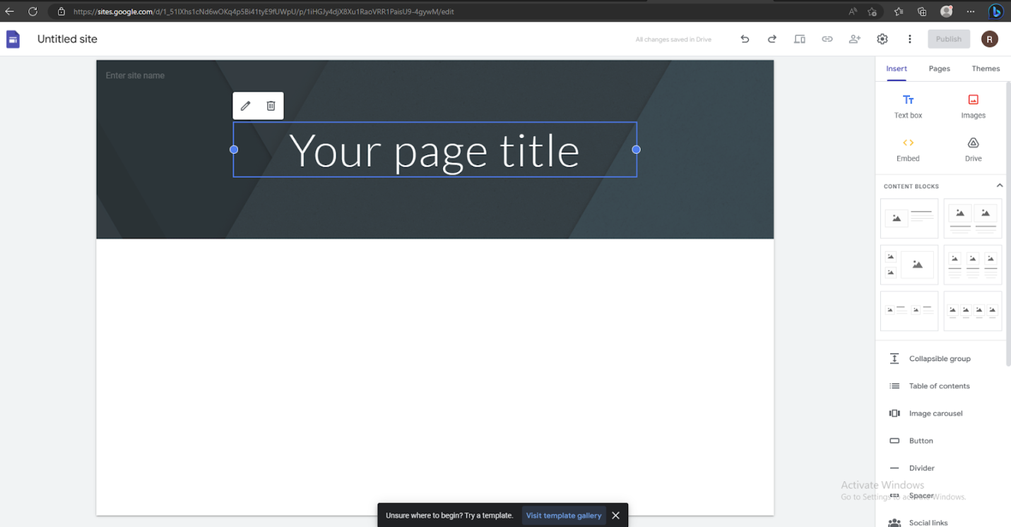

### Cloud Computing Week - 7

**PLATFORM AS A SERVICE**

* Platform as a Service (PaaS) is a cloud computing model that provides a platform for developers to build, deploy, and manage their applications without having to worry about the underlying infrastructure.
* In a PaaS model, the cloud provider provides the hardware, operating system, and middleware required to develop and run applications, while the developers focus on building and delivering their applications.

**Amazon Web Services (AWS)**

Amazon Web Services (AWS):

AWS, which stands for Amazon Web Services, offers several services that fall under the Platform as a Service (PaaS) category. These services provide developers with pre-configured environments for developing, testing, and deploying their applications in the cloud. Here are a few examples of how AWS works on PaaS:

1. AWS Elastic Beanstalk: AWS Elastic Beanstalk is a fully managed PaaS offering that enables developers to easily deploy web applications using popular programming languages, such as Java, .NET, PHP, Node.js, Python, Ruby, and Go. Elastic Beanstalk takes care of the underlying infrastructure and automatically scales the application as needed.
2. AWS Lambda: AWS Lambda is a serverless computing platform that allows developers to run code in response to events, such as changes to data in an Amazon S3 bucket or an update to a database. Developers can write code in popular programming languages, such as Java, Python, and Node.js, and Lambda takes care of the underlying infrastructure and scaling.
3. AWS App Runner: AWS App Runner is a fully managed service that makes it easy for developers to build, deploy, and run containerized applications in the cloud.

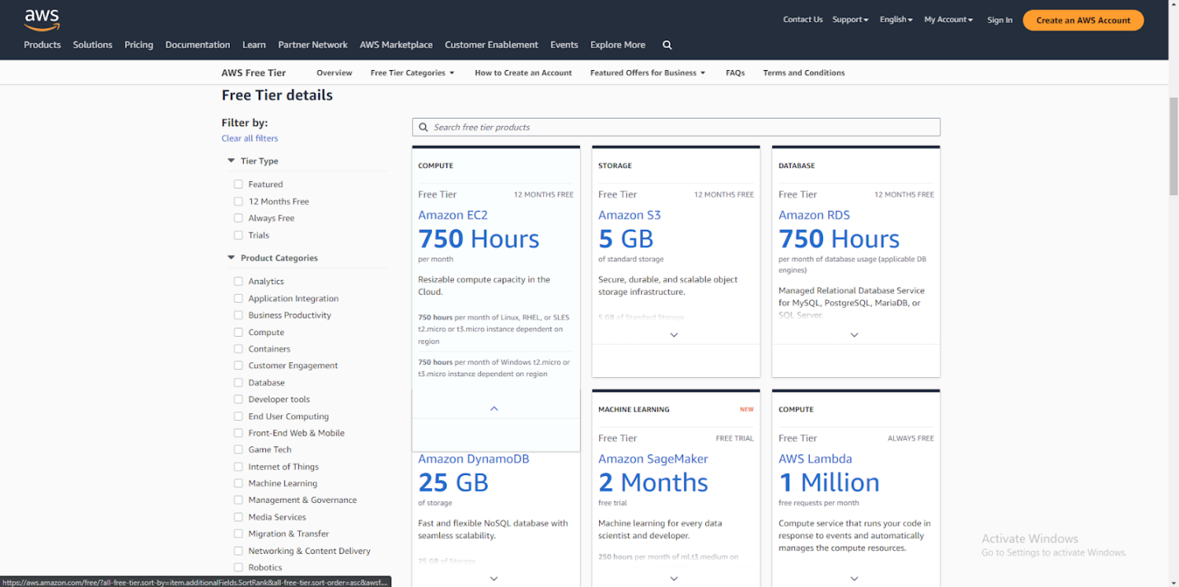

**Microsoft Azure**

                Azure is a Platform as a Service (PaaS) provider. Azure is a cloud computing platform provided by Microsoft that enables developers to build, deploy, and manage applications without having to worry about the underlying infrastructure. Azure provides a range of services and tools that help developers build and deploy web and mobile applications, including databases, middleware, development tools, and more.

                Azure supports several programming languages, including Java, Node.js, Python, and PHP. Developers can easily deploy their applications to the Azure platform using Git or other source control tools, and Azure takes care of the rest, including scaling, load balancing, and managing the infrastructure.

Azure is known for its flexibility, scalability, and integration with ot   her Microsoft services and tools, making it an ideal choice for businesses of all sizes. Azure also offers a range of pricing options, including a free tier, making it accessible to developers of all levels.

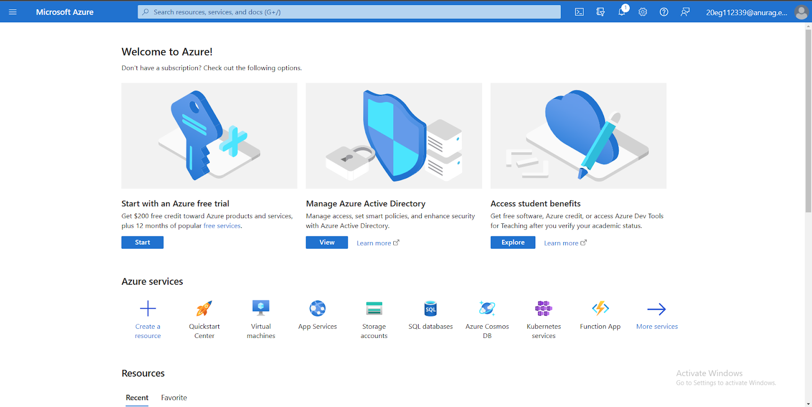

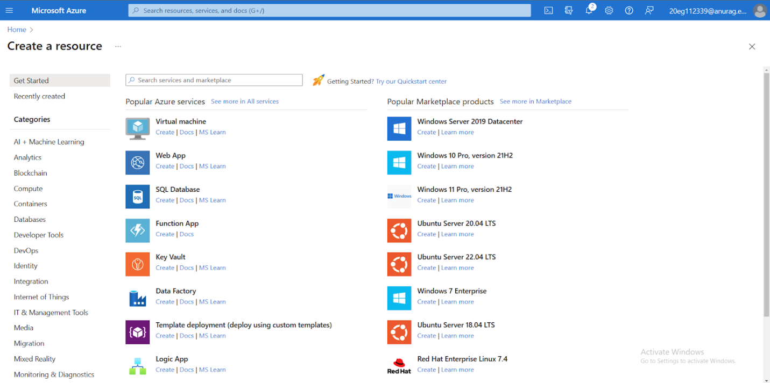

**STREAMLIT**

**Streamlit** is a platform as a service (PaaS) application.

* Streamlit is a web application framework for creating interactive data science and machine learning applications, allowing developers to create, share, and deploy their applications to the cloud.
* Streamlit provides a set of tools, libraries, and templates that simplify the development and deployment process, while also providing scalability, security, and reliability through cloud-based infrastructure.
* As a PaaS application, Streamlit provides a convenient and cost-effective way for developers to build and deploy their applications, without the need to manage the underlying infrastructure or worry about scalability and availability.

